**ID2 User manual**

2020년 10월

**INDEX**

1 Install 3

1.1 Program Install 3

1.2 Program Execution 4

2 Preset 5

2.1 Program Registration 5

2.2 Screen Layout 6

2.3 Setup Configuration 8

2.4 Setup Area 19

2.5 Export 20

2.6 Set up Code table 21

2.7 HMB Data 24

2.8 Custom Code Table (Mainly for Instrument Module) 25

2.9 Replace Code Table (Mainly for Instrument Module) 26

2.10 Setup Special Item Type 27

2.11 OCR Training 28

2.12 Symbol Training 29

2.13 Make Label Data 29

2.14 Symbol registration 30

2.15 Add symbol Attribute 32

2.16 Symbol Manager 34

3 Recognize 36

3.1 Character recognition 36

3.2 Drawing recognition 37

3.3 Modifying recognition results 40

3.4 Attribute link 44

3.5 Find/replace 47

3.6 Text Data List 47

3.7 Replace or Insert Symbol 49

3.8 OPC Relation 51

3.9 Streamline settings 52

4. Report 53

4.1 Design information list 53

5. View 56

6. Convert PDF 57

7. Importing data (lines, text)) from CAD 57

8. Importing text from PDF (Instrument extension) 58

9. Enhanced symbol thickness 58

8. Data Migration 59

9. Export 60

10. Troubleshooting procedures 61

# Install

## Program Install

* Click Next to install  
   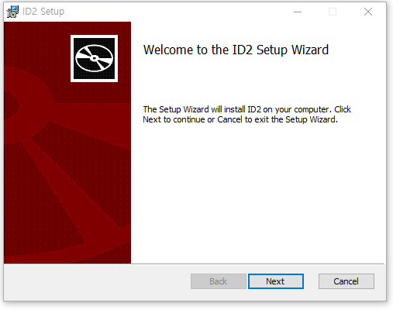

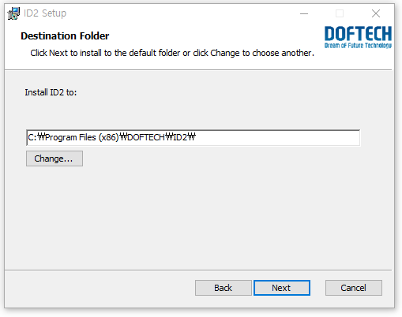  
  
 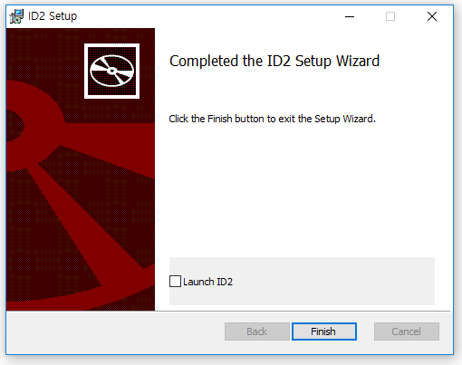

## Program Execution

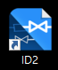

* Double-click the ID2 icon on the desktop.
* The screen appears to register the license key.  
  Enter the license key issued by the computer name.  
  Send an email to (noon.jang@samsung.com) to get a license key.

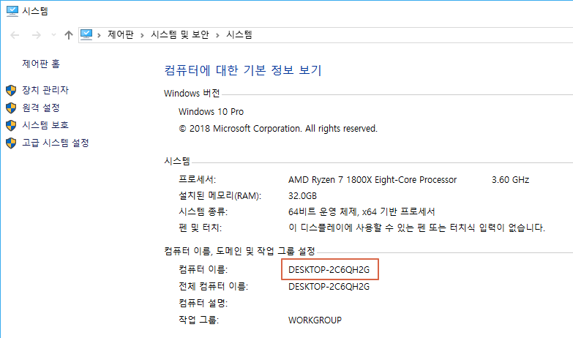

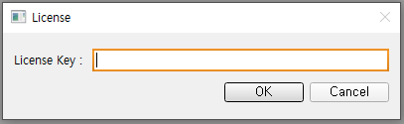

# Preset

## Program Registration

* Press the right + button to register a folder containing P&ID.

**Project name must not contain spaces.**

* Project Desc: Complete the project description.

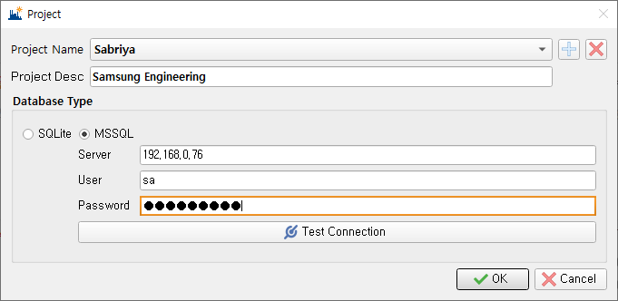

* Set up the database after project registration.
  + SQLite: Default database format.
  + MSSQL
    - Server: Enter IP where MSSQL server is installed.
    - User: Enter the user name to connect to the MSSQL server.
    - Password: Enter the user password.
    - Test Connection: MSSQL server connection test is performed using the entered information.
* You can move the drawing image into the created drawings folder or create a drawing image from PDF through the program's **Tools> Convert PDF function**.
* “5. Convert PDF” reference

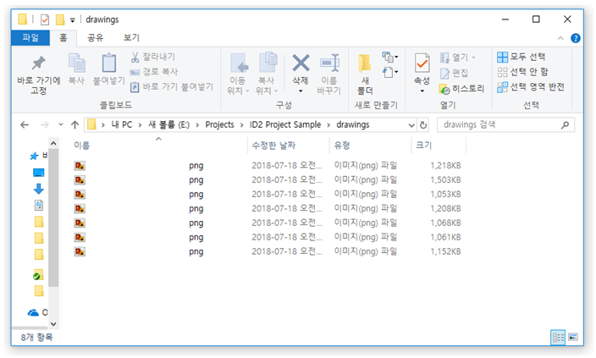

## Screen Layout

* This is the main screen of ID2

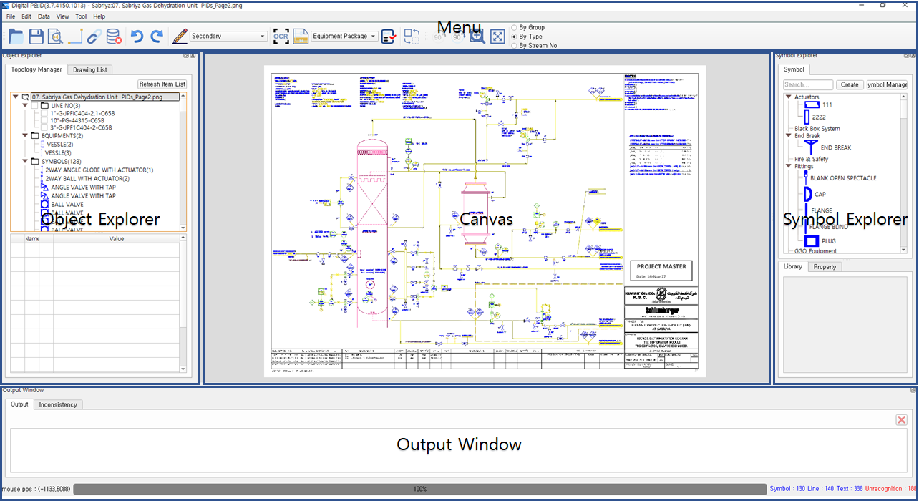

Object explorer, symbol explorer, output window, etc. can be resized and positioned with the mouse.

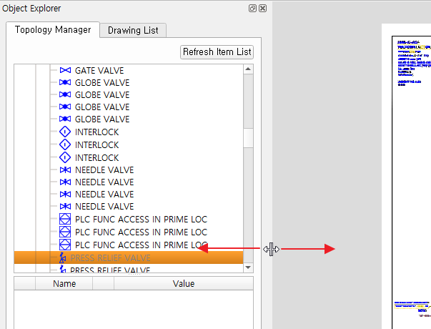 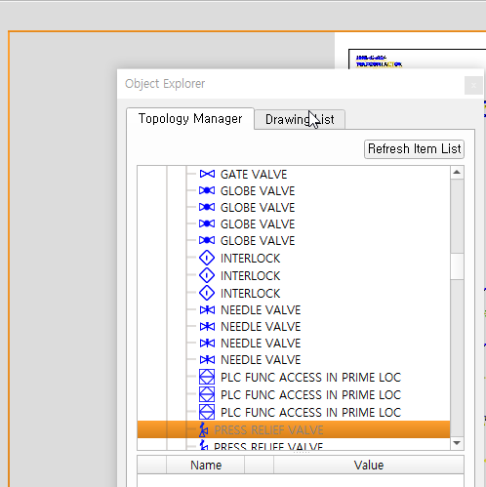

Figure 1 Resize Figure 2 Move Position



Press or drag above part

When running the program, the size and position of the screen are set to the size and position adjusted by the user.

* + Menu Bar   
    The ID2 function is configured in the form of an icon or a list.
  + Object Explorer  
    - Drawing List: Drawings to be recognized are in List format.

- Object Explorer: Recognized symbols, lines, etc. are displayed in a hierarchical list format.

* + Canvas  
    This is the area to display or edit the recognized drawing.
  + Symbol Explorer  
    Register a symbol or display the registered symbol in a hierarchical list. When adding a symbol to the canvas, drag and drop the symbol and click on the corresponding position on the canvas.
  + Library: You can increase the convenience when working with drawings by dragging and dropping symbols that users frequently use in the symbol explorer and adding them to the Library.

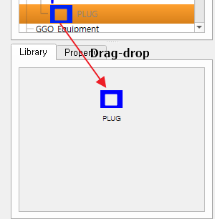

Create new symbols on the canvas by dragging and dropping symbols in the library.

* + Property: check the properties of the selected symbol.

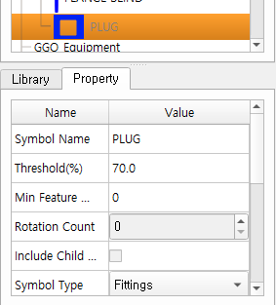

* + Output Window  
    Output: Error logs and items with problems during verification are indicated.
  + Adjust Layout  
    As for the layout of each window, if you drag the head of the window and try to put it in the existing window, a different layout is suggested.

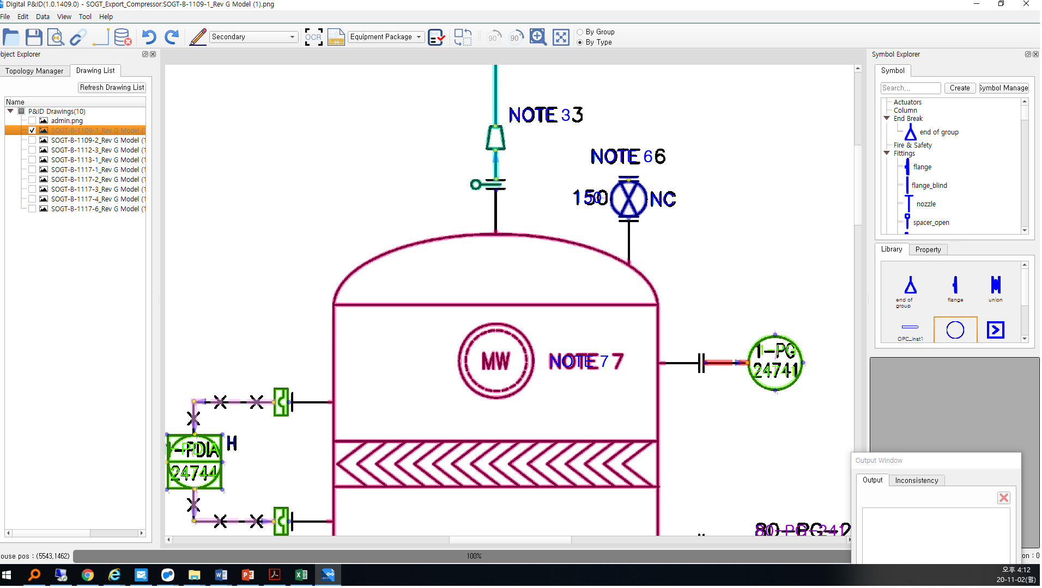

## Setup Configuration

* Click [File] - [Configuration] menu.

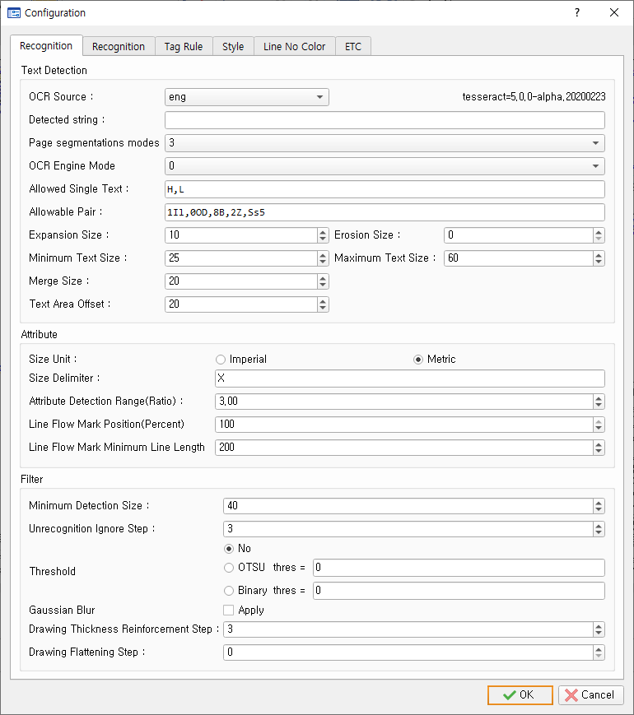

* + Text Detection
    - OCR data: Set the OCR data to use when recognizing text.  
      The default is English, and if you have generated OCR data through in the project, you can use the OCR data as the project name.
    - Detected String: Enter the texts to be detected with OCR. OCR texts that are not included in this string are not recognized as OCR.
    - Page Segmentation modes: Select segmentation mode for use in Tesseract (0 to 13). The default is 12.
    - OCR Engine Mode: Select Tesseract Engine Mode (0 ~ 3). The default is 0.
      * 0 : Legacy engine only
      * 1 : Neural nets LSTM engine only
      * 2 : Legacy + LSTM engines
      * 3 : Default, based on what is available
    - Allowed Single Text: OCR separates the texts to be allowed to enter into comma when one text is recognized.
    - Allowable Pair: Code Table registers the pairs of texts to be used for auto allowable functions by separating them into comma. Ex) 1Il,0OoD,8B,2Zz,Ss5,Cc,Pp,Uu,Vv,Ww,Jj,Yy,Xx

[2.6] – see [Auto Allowable]

* + - Expansion, erosion size: Set the size of the image to expand (thicken the letters) and erosion (thin letter) before recognizing it as OCR.
    - Set the minimum, maximum size of the text to recognize with OCR the minimum, maximum size.  
      Text that is recognized outside this size is ignored by the program.
    - Merge size: Sets the merge size to connect recognized strings.  
      Increase the area of the recognized string by the size of the merge to treat the strings that are attached to each other as a single string.
  + Attribute
    - Size Delimiter: Set the separator of Main Size and Sub Size of Reducer.
    - Attribute Detection Range (Ratio): Set the navigation range when connecting between items.
    - Line Flow Mark Position (Percent): Set where Flow Mark will be placed.  
      100%: Flow Mark generation on the end point of the line.  
      50%: Flow Mark generation in the middle of the line.
    - Line Flow Mark Minimum Line Length: The minimum line length that can generate Flow mark.
  + Filter
    - Minimum detection size: Minimum size of object to detect
    - Unrecognition Ignore Step: Noise removal step when creating unrecognized objects
    - Threshold: Gray drawing binary
      * No: Keep gray drawings
      * OTSU: Use the OTSU method to binary drawings (automatically threshold)
      * Binary: Specifies a threshold to binary the drawing  
        (values smaller than the threshold are black, and larger values change to white.)
    - Gaussian Blur: Gaussian Blur Application Status Settings
    - Drawing Thickness Reinforcement Step: Steps to thicken drawing images
    - Drawing Flattening Step: Drawing image flattening phase (flat surface)

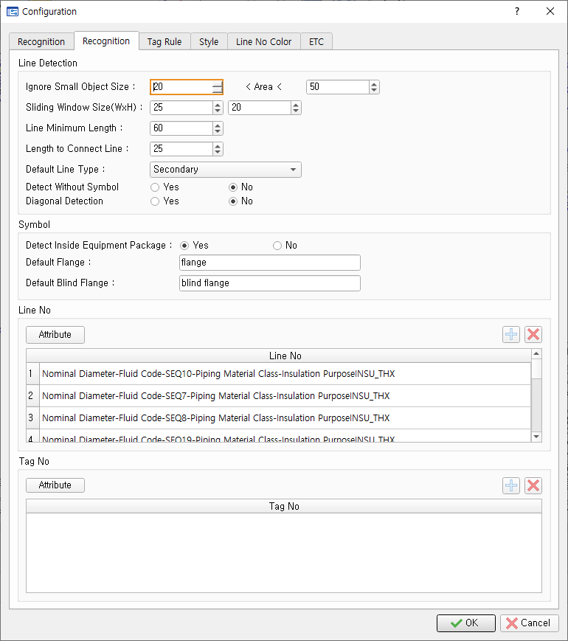

* + Line detection
    - Excluding small object size: minimum size to exclude from line detection
    - Sliding window size: window size to use for line detection
    - Minimum line length: Ignore lines that are smaller than the minimum line length set after line detection.
    - Length to Connect Line: Maximum threshold for between lines connections
    - Default Line Type: Line type default
    - Detect Without Symbol: Set whether to detect lines that are not connected to the symbol.
    - Diagonal Detection: Set whether to detect non-horizontal, non-vertical lines.
  + Symbol
    - Detect Inside Equipment Package: Equipment package sets whether to recognize objects inside.
    - Default Flange: Set the default Flange symbol name.   
      (Used to create Flange shape after drawing recognition)
    - Default Blind Flange: Set the default Blind Flange name.   
      (Used to create Blind Flange shape after drawing recognition)
  + Line number: Text that meets line Number conditions is converted to Line No.
    - Attribute: Set the attributes to configure Number.

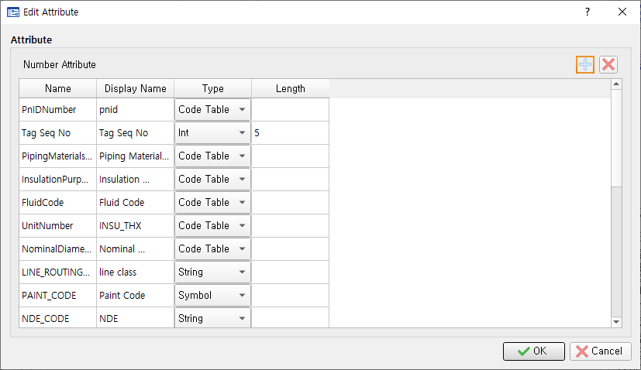

* + - * You can add/delete attributes with the +/- button.
      * If you use Type as Code Table, you must set the name of the Code Table to use the items in the Name column.
    - Add(+): You can add a new number rule by pressing the Add button.

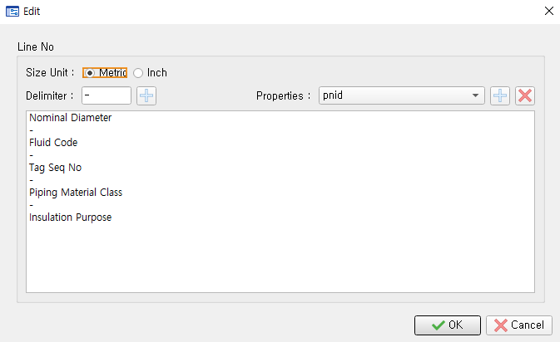

Ex) 아래 Line Number의 경우, 위와 같이 등록

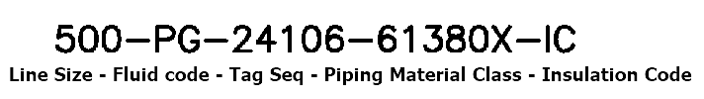

* + - * Size Unit: Set the Unit Size used by the line number.   
        (Metric, Inch can be selected)
      * Delimiter: You can set the separator, not the line number attribute you set up earlier.  
        Press the add button next to it to add it.
      * Properties: Select the number property.   
        Press the add-on next to add the number property.
      * Delete: Delete the selected number property.
    - Delete: Press the Delete button to delete the selected number rule.
  + Tag No: Text that meets the Tag No conditions is converted to Tag No.
    - Attribute: Setthe attributes to configure Tag No.



* + - * You can add/delete properties with the +/- button.
      * If you use Type as Code Table, you must set the name of the Code Table to use the items in the Name column.
    - Add (+): You can add a new Tag No rule by pressing the Add button.

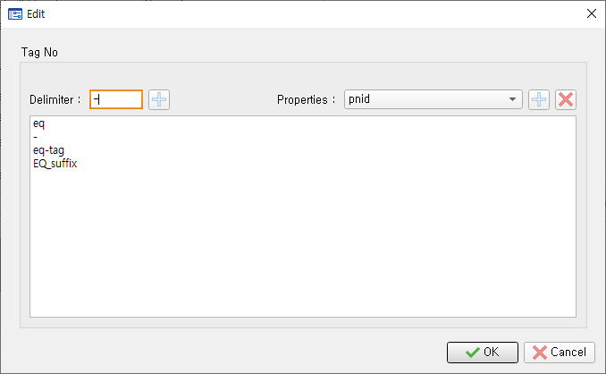

Ex) 아래 Tag Number의 경우, 위와 같이 등록

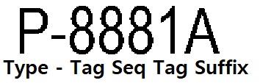

* + - * Delimiter: You can set the separator, not the Tag No attribute you set earlier.   
        Press the add button next to it to add it.
      * Properties: Tag Select the No property.   
        Press the add-on button next to add the Tag No property.
    - Delete(X): Press the delete button to delete the selected number rule.
  + Tag rules: Set the detection form of notes and nozzles.

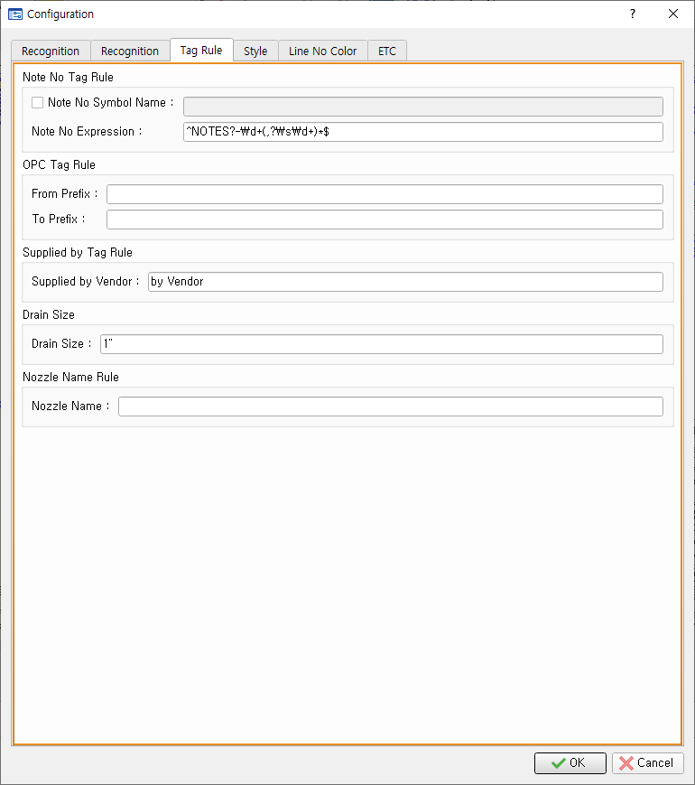

* + - Note number rules
      * Note Number Symbol Name: Set the symbol name to use as a note.
      * Note Number Expression: Set the note number text regular expression.   
        Example) ^NOTE\s\d+ (,\d+)*$: "NOTE 3", "NOTE 3,4", "NOTE 3,4,5", etc. :   
         ^ : Start character  
         note: string  
         \s: blank

\d: Number

+: Repeat once

,: String

( )* : Parenthesis content is repeatable

$: end letter

* + - OPC Tag Rule
      * From Prefix: Fill in From Prefixto to recognize OPC Tag.
      * To Prefix: Fill in to prefixto recognize OPC Tag.
    - Supplied by Tag Rule
      * Supplied by Vendor: Set the value to go into the **Supplied by Vendor** property of an item belonging to the Vendor Package.
    - Drain Size
      * Drain Size: Set the default size of DrainPipe.
    - Nozzle name rules
      * Nozzle Name: Enter the nozzle name rule.
  + Notation

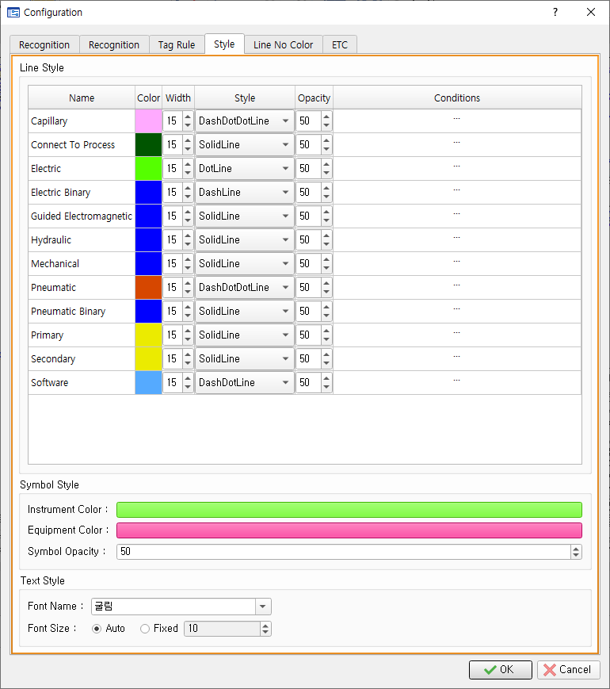

* + - Line Style: Set the style (Color, Width, Style, Opacity) and Condition of the line by attributes.
      * Condition: When you double-click on the Condition cell, the window below appears.   
        Enter the conditions under which you want to set the line type.   
        Type: Select Line or Symbol.

Itme Type Names: Enter the type of line or symbol connected to the left and right separated by a comma (,).

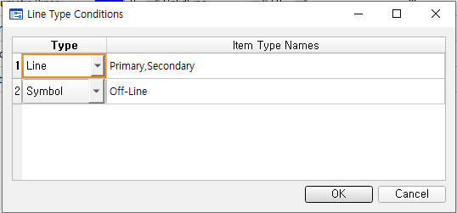  
The line type is automatically updated according to the conditions set when linking properties.

* + - Symbol Style
      * Instrument Color: Set the color of Instrument Symbol.
      * Equipment Color: Set the color of the Equipment symbol.
      * Symbol Opacity: Set the transparency of the symbol.
    - Text Style
      * Font name: Set the font name to use for text notation.
      * Font Size: Set the size of the font to use for text notation.   
        - Automatic: Set the font size automatically to fit the text area.   
        - Fixed: Set the font size to the set value.
  + Line Number Color: Set the color of the line number.

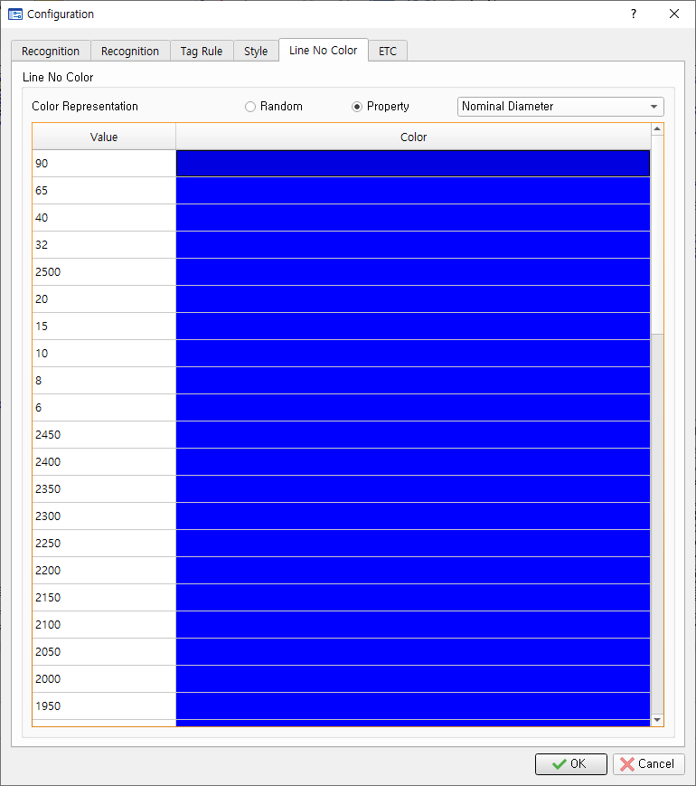

* + - Random: Set the color randomly
    - Property: You can set the color to the value of Line No Property
    - You can double-click on the Color item to set the color you want.

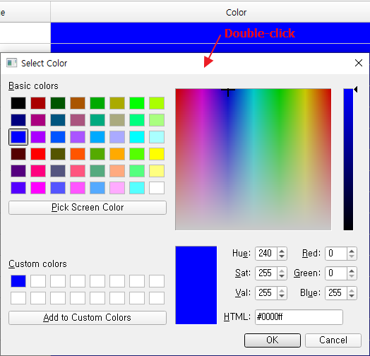

* + ETC

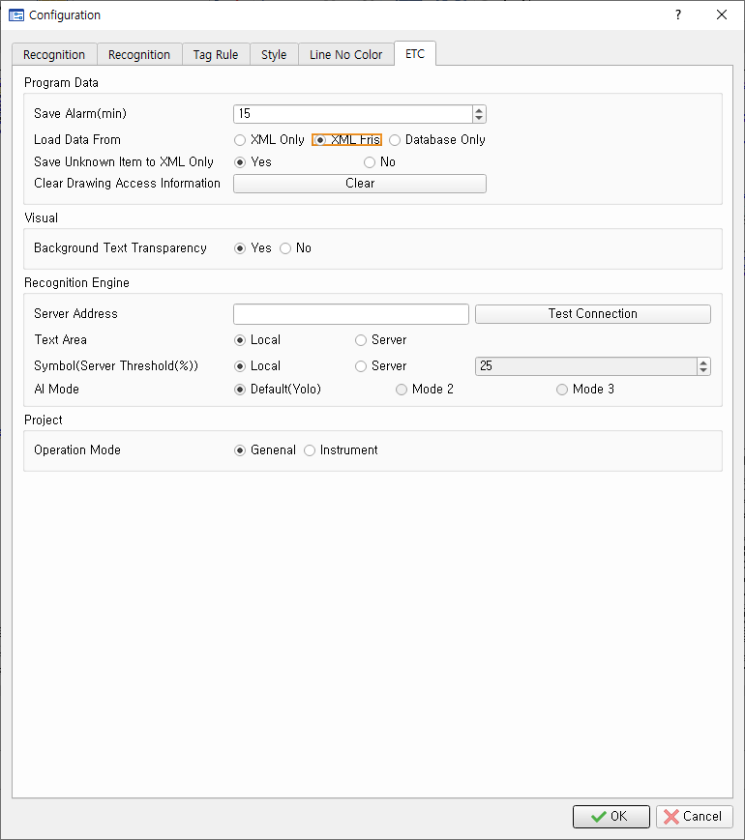

* + - Program Data
      * Save Alarm (min): When the user is not working, the set value passes, and the save message window pops up.
      * Load Data From:
        + XML Only: When open a drawing, it reads data from XML.
        + XML First: Same as XML Only.
        + Database Only: When open a drawing, the data is taken from the database (SQLite, MS-SQL).
      * Save only unrecognized objects XML: Set whether to store unrecognized objects only in XML files.
      * Initialization of drawing access information: Initializes user information that is connected to the drawing.
        + When someone tries to access the drawing in which they are working, the message window below appears

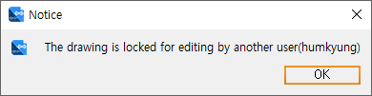

* + - Visual
      * Erasing background text: Set whether to clear the background of the recognized text.
    - Recognition Engine

SECL default Server : http://66.85.151.90:1073

* + - * Server Address: Enter the server address with the AI engine installed.
      * Text Area
        + Local: Extracts the text area from theD2 itself.
        + Server: Extracts the text area from the server. (Using craft algorithms) - Recommended
      * Symbol (Server Threshold (%))
        + Local: ID2 performs symbol recognition on its own. (Recommended)
        + Server: Performs symbol recognition through the server's AI engine.
      * AI Mode: Set the AI engine type.

## Setup Area

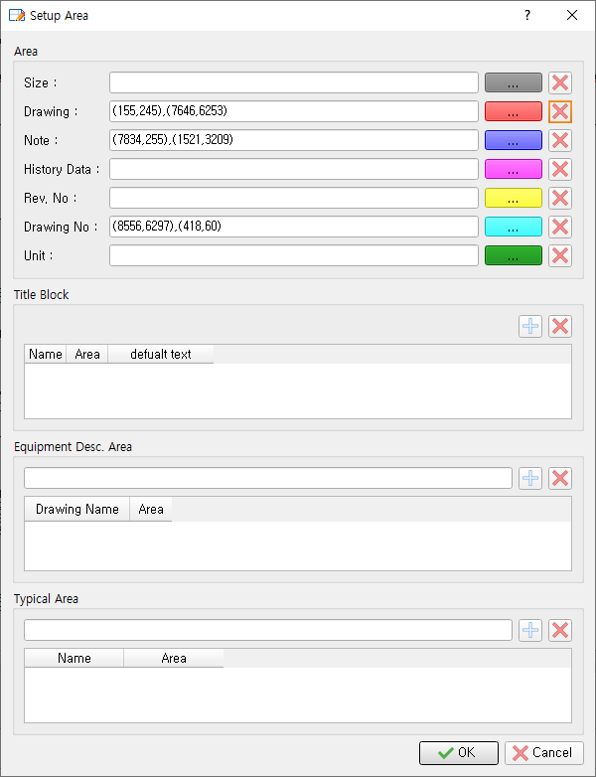

* [File] –[Open] or tap the icon to load the drawing.
* [File] - [Setup area].
  + Area: Set the common property area of the drawing.
    - Size: Set the entire drawing area.
    - Drawing: Graphics area in P&ID.
    - Note: Area where Note description was written
    - History Data: Area where revision history in drawings was written (coming later)
    - Rev. No: Area where revision No in the drawing was written
    - Drawing No: Area where drawing number was written
    - Unit: Area where Unit was written
  + Title Block
    - Name: Enter the name of the title block.
    - Area: Set the area of the title block.
    - Default Text: Sets the default value for the title block.
  + Equipment Desc: Set the Equipment Desc. area.
  + Typical T area: Set the Typical area.

## Export

The current open drawing can be stored in the selected format (SVG, XML, Image).

* [File]-[Export] In the menu, select the file format you want to save.
* Set the file path to save.

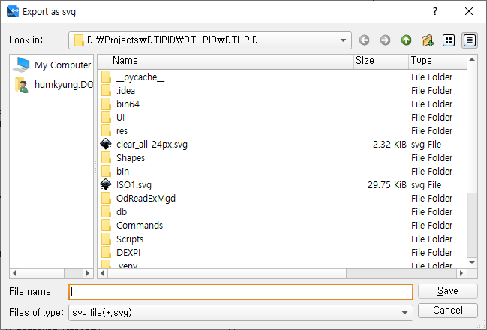

## Set up Code table

* Click [Data] - [Code Table].

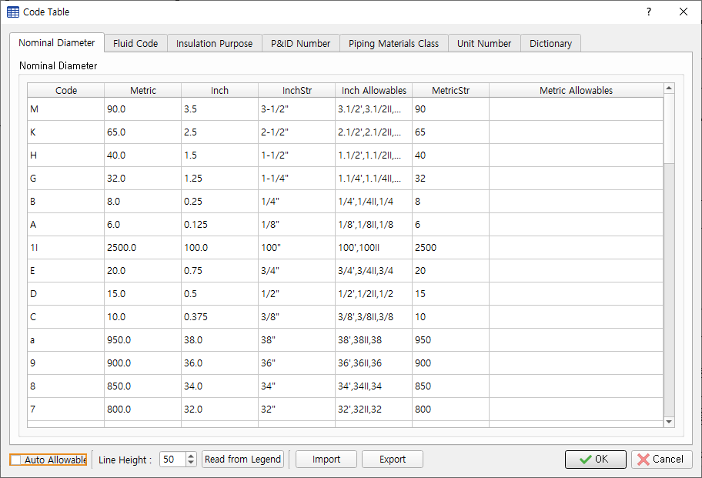

* + Code Table: Sets the code, description, and values of the properties to be recognized by the line number into comma (,).

You can set up Fluid Code, Insulation Purpose, P&ID Number, Piping Materials Class, Unit Number, Dictionary.

* + Nominal Diameter: Set by Line Size. When you create a project, the default slot is saved.
  + You can edit the code and properties through copy/paste.
  + Import: Use excel files to create a code table.   
    (Note: The contents of the existing code table will be deleted.)
    - In the file selection window, select the Excel file.  
      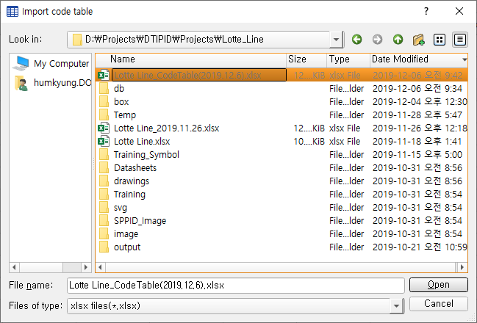
  + Export: Store the contents of the code table as an Excel file.
    - Set the location and name of the Excel files to be created in the file selection window.  
      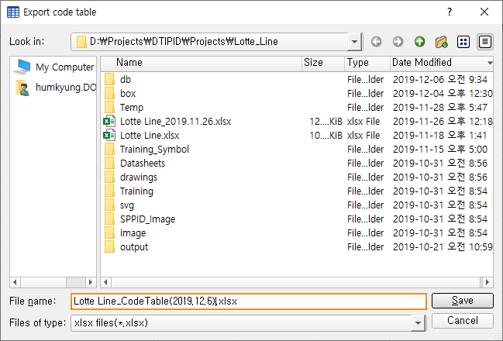
    - When the export is complete, a confirmation window will appear.  
      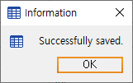
    - OK: Applies the contents of the code table to the system and stores them in the database.
  + Read From Legend: Read the code table in the Legend area.
    - Line Height: The height of the code lines recorded in Legend
    - Whenbutton click, It changes to and drags the code part in Legend.

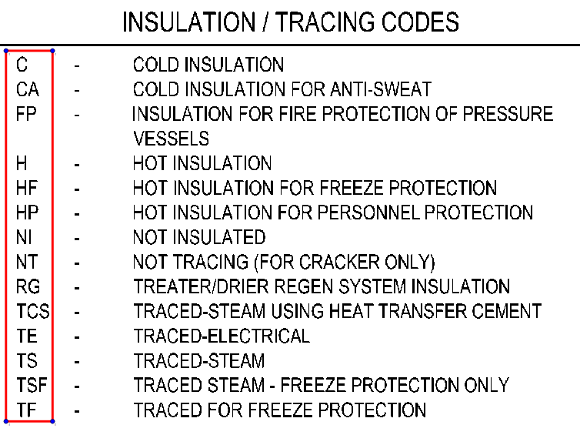

* + - After setting the code area, the button changes to, and drags the code description part in consecutively.

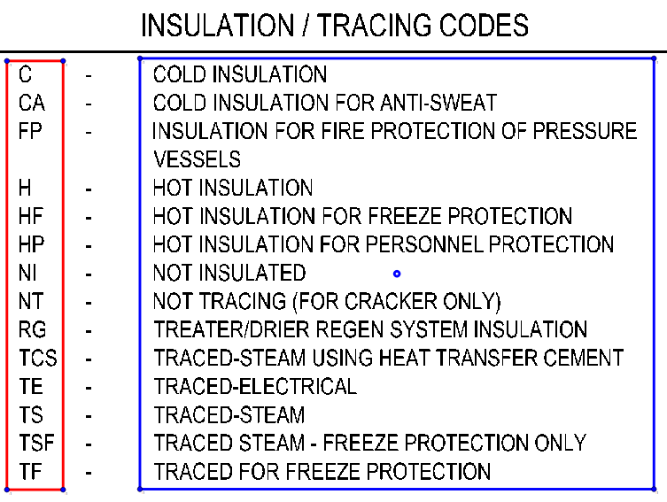

* + - After adjusting each area box,  click the button to read the code.

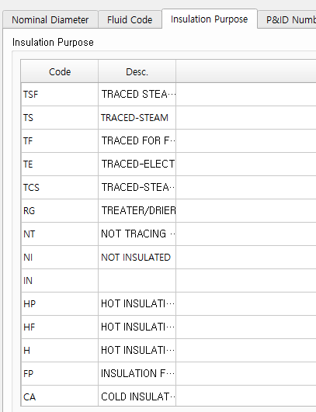

Figure Results

* + - Auto Allowable: Select a check box and enter a Code column, or use the [Read from Legend] function to automatically generate an Allowable column. [2.3] – [Allowable Pair] Uses the set values.

## HMB Data

* [Data] - [HMB Data] Click on the menu.

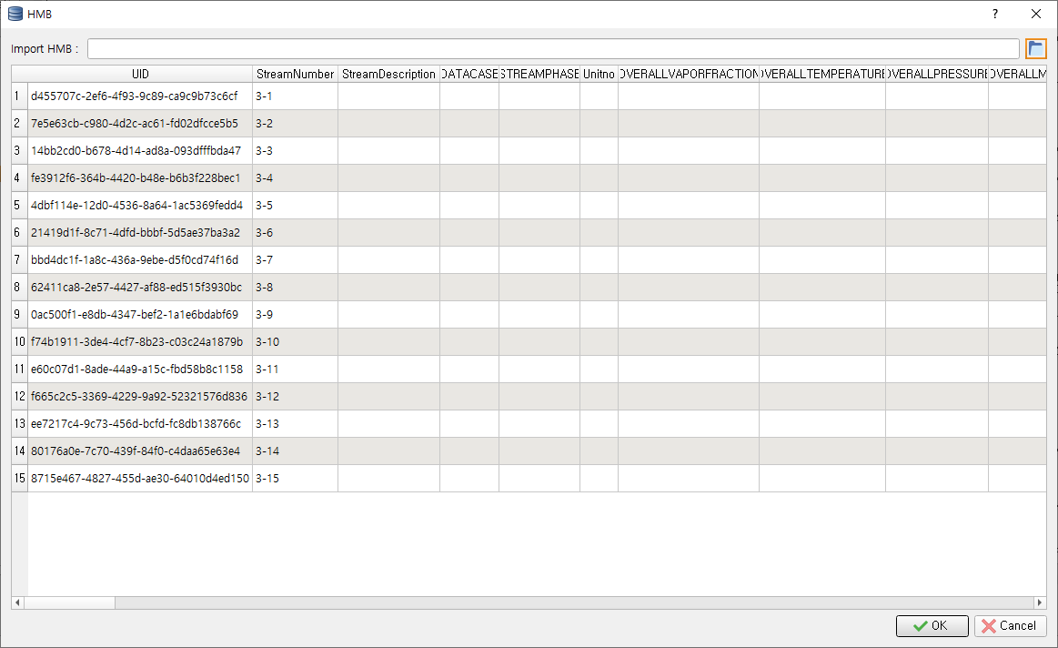

* Select the HMB Data Excel file.

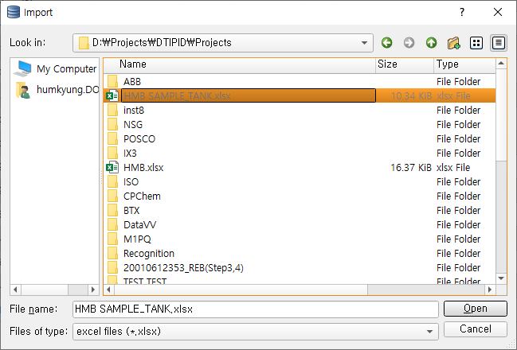

* + Read HMB Data from the selected Excel file and save it to the database.

## Custom Code Table (Mainly for Instrument Module)

* [Data] – [Code Table] Create additional tables other than the tables provided by if necessary.
* Click [Data] – {Custom Code Table} menu.

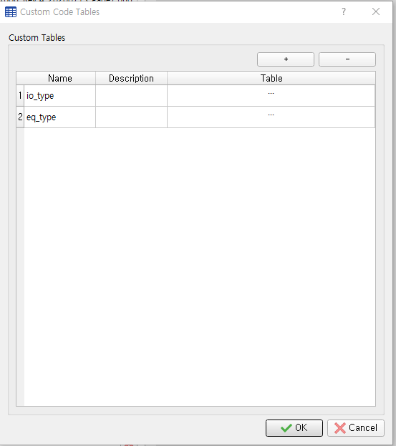

* After clicking the [+] button, enter the table name you want to use in the Name column, and then double-click the Table column.
* [Data] – [Code Table] Write the same as.

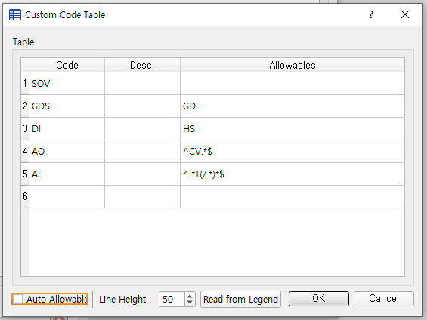

## Replace Code Table (Mainly for Instrument Module)

* Set the table to use when extracting the list of instruments.
* Click [Data] - [Replace Code Table] menu.

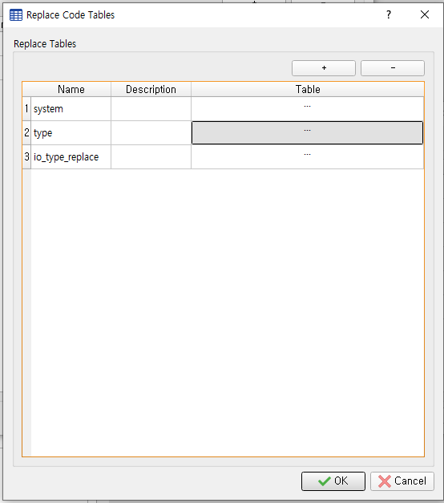

* After clicking the [+] button, enter the table name you want to use in the Name column, and then double-click the Table column.
* Words registered in the Code column are replaced by words in New Code based on conditions.

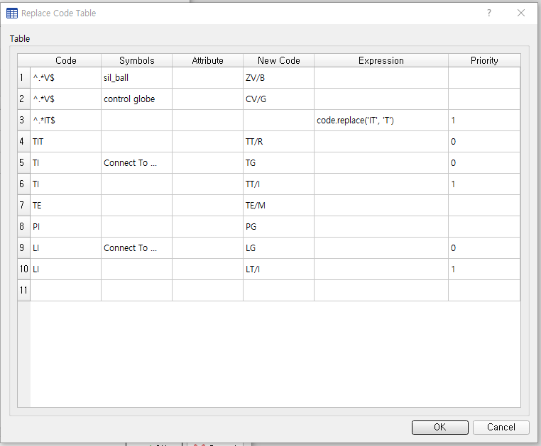

* Code (input): Allow Multiple inputs separated by comma [,] allow words to be typed, blank slot allowed, regular expression allowed.
* Symbols (conditional): Inspect whether the symbol with the code is connected to the entered symbol or line type. Allow Multiple inputs separated by comma [,].
* Attribute (condition): When used with Symbols, checks that the specified symbol contains the value entered in the Attribute as a property. Check that your property contains the entered value when you use it alone.
* New Code (output): The word entered in the code is the word that will be converted if the condition is met.
* Expression (output): Converts a word or other attribute value entered in a code to a value other than the specified New Code using an expression.
* Priority (condition): When the input value satisfies conditions for multiple rows, a row with a lower input numeric value is selected.

## Setup Special Item Type

* Set the type of Special Item that appears in the drawing. When linking design information, you can recognize the Special items and store them in a database and output them as Excel files.

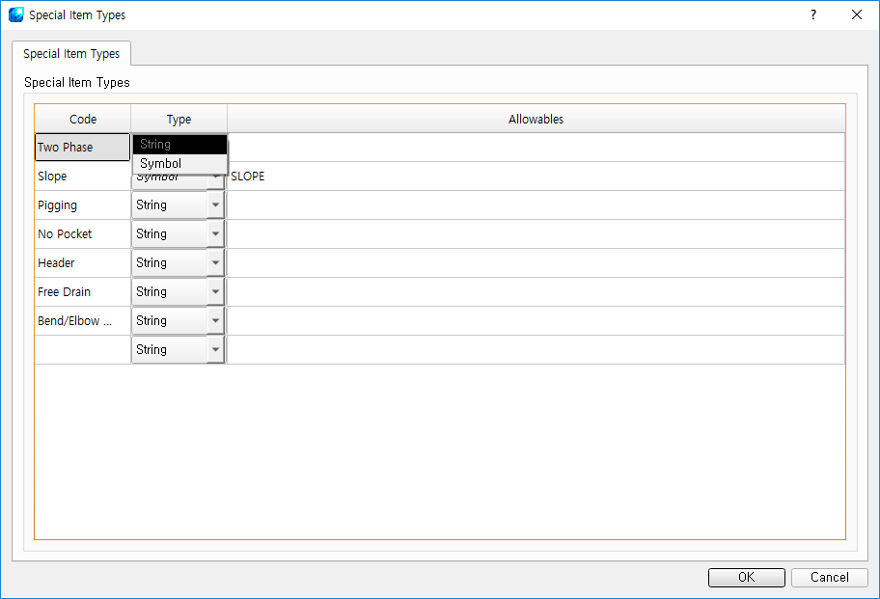

* + Code: Enter the code to distinguish Special Item.
  + Type: Set the kind of Special item. You can choice between String and Symbol.
  + Allowables: Enter the name of the text or symbol that you recognize as the Special Item. You can enter multiple text or symbol names by separating them into comma.

## OCR Training

* Click [Data] - [Learn Letters] menu.

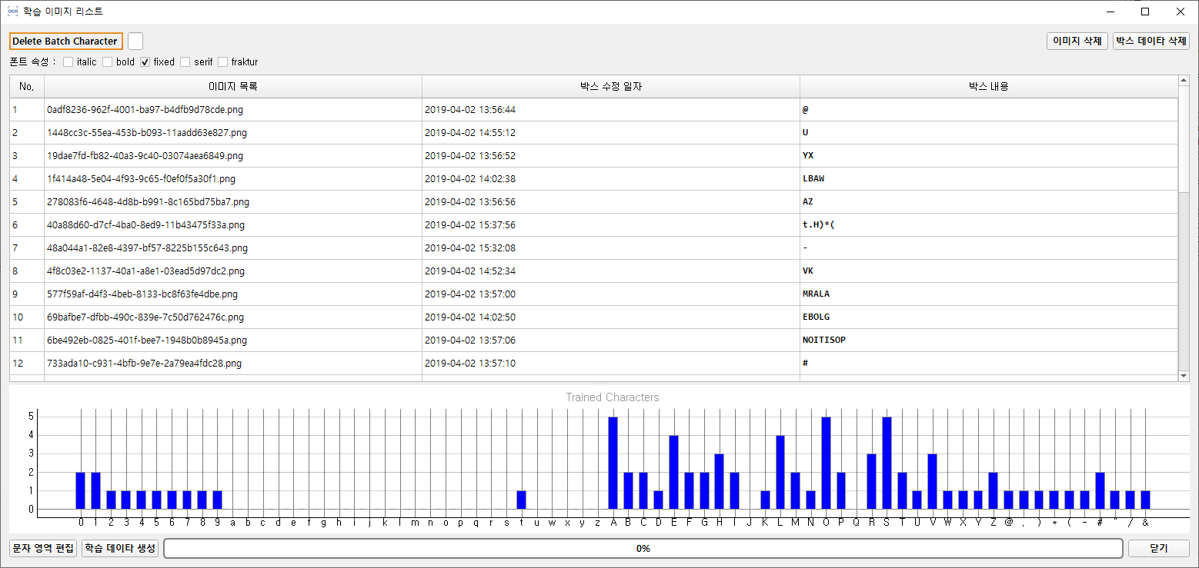

* + Delete Batch Character: Delete a batch of specific characters from the box content created. (Non-recoverable)
  + Delete images: Delete selected images and dependent box data.
  + Delete box data: Delete the box data used to learn of the selected image.
  + Font properties: Set the properties (italic, bold, fixed, serif, fraktur) used for OCR training.
  + Edit character area: Double-click on an image or click the Edit [Edit character area] button to edit the character area for the selected image.

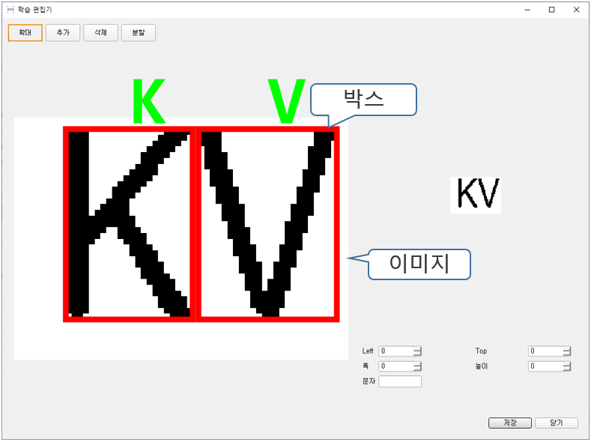

* + - Set the size of the individual characters (Left, Top, Width, Height) and the character values.
    - Zoom in: Zoom in on the image.
    - Add: Add a new text box behind the selected text box.
    - Delete: Delete the selected text box.
    - Split: Split the selected text box.
    - Character Settings: Connect characters by typing characters while selecting a character box.
    - Move the character box: You can move between character boxes by pressing the left/right arrow keys while selecting the character box.
  + Generate Training Data: Generate OCR training data by project name.

## Symbol Training

* Click [Data] - [Symbol Training] menu.

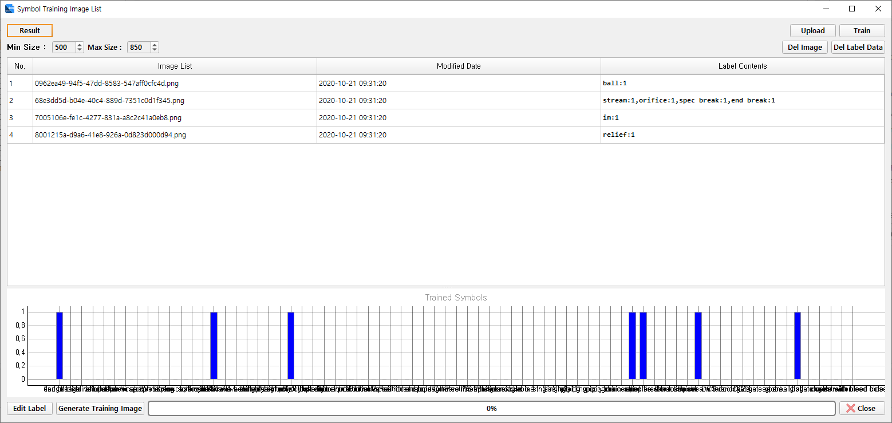

* Upload: Upload the written learning data to the server.
* Train: Train AI model based on uploaded training data.
* Del Image: Delete registered images and label data.
* Del Label Data: Delete the label data written in the image.
* Result: Check the learning results.
* Edit Label: Edit the label data for the registered image.
* Generate Training Image: Merges the extracted symbol images from the drawing to create a learning image.

## Make Label Data

* The symbol touch-up automatically generates learning label data from the completed drawing.
  + Load the drawing with the complete symbol touch-up.
  + Click [Data] - [Make Label Data] menu.
  + View the generated label data in [Data]- [Symbol Training].

## Symbol registration

Register symbols that you will recognize before drawing recognition.

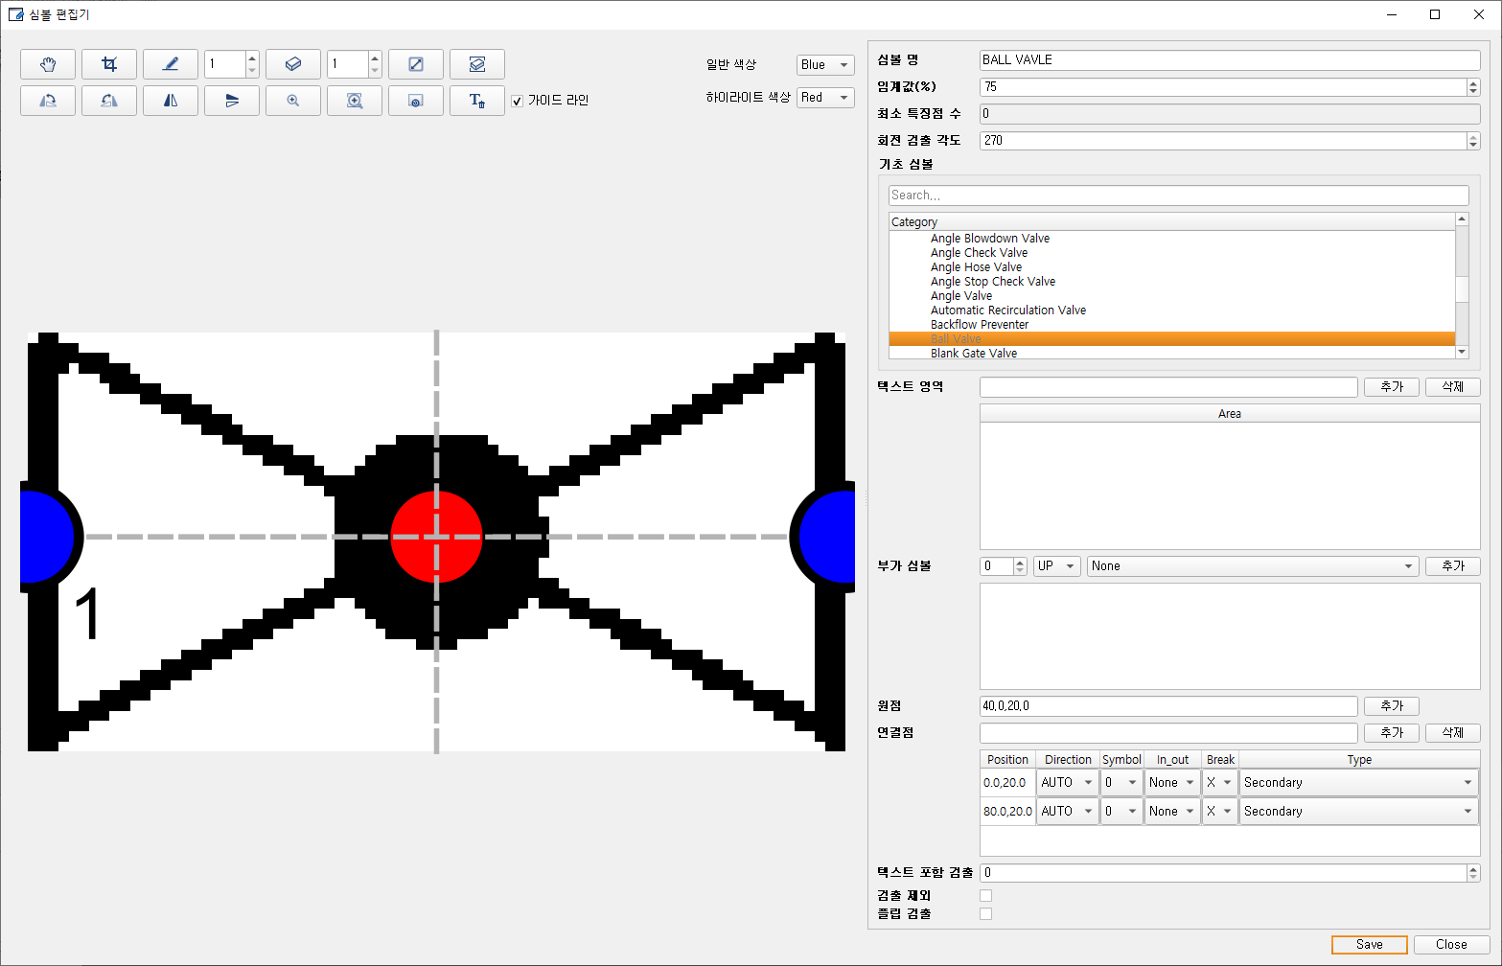

* Click [Create] in the right symbolic navigator and drag the symbol you want to register in the drawing.
  + Symbol Editor: Edit the image so that the symbol fits the area and fill in the properties.  
    Sets the center of the symbol and the connection points.
  + Threshold (%): Sets a threshold to determine whether a symbol is recognized or not. For example, if you set it to 75%, only symbols with a recognition rate of 75% or more will be recognized.
  + Rotation detection angle:
    - 0: Do not rotate.
    - Rotate 90: 0, 90 degrees to recognize symbols.
    - Rotate 180: 0, 90, and 180 degrees to recognize symbols.
    - 270: 0, 90, 180, 270 degrees rotate to recognize symbols.
  + Basic symbols:
    - You can search for basic symbols by typing text in the search box.

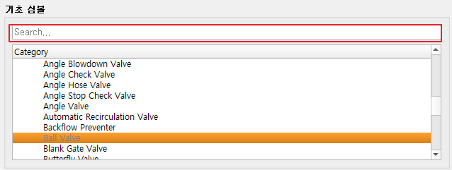

* + - Set the foundation symbol.
  + Additional symbols: For example, when you create a control valve + Operator as a symbol, set the control valve as the base symbol and operator as an add-on symbol.   
    The additional symbol sets the direction and symbol type in which the add-on symbol is attached.
  + Origin: Set the base point of the symbol.
  + Connection points: Set the connection points in the order of left, (🡪(1) right((2), down((3) 🡪 up(4). Left and right, down and up are connected to each other to determine In, Out.
    - Symbol: Select a symbol index with a connection point.   
      If there is only the default symbol, select 0, and the index of the add-on symbol increases from 1.
    - In_out: Select the direction of fluid progression at the connection point.   
      - None: Do not set fluid direction  
      - In: Fluid enters  
      - Out: Fluid out
    - Break: Set whether to create Line Break.   
      - O: Line Break Generation  
      - X: Line Break Not Generation
    - Line Type: Select the line type connected to the connection point.
  + Minimum Number of Text: Determine the minimum number of texts to include in symbolic detection. Ignore the detection results if the number of text inside is less than the set number after detection. (OPC, Label, etc.)
  + Not included in detection: Not included in detection: Excluded in symbol detection during check.
  + Flip detection: Check also detects left and right reversible shapes.
* Edit Symbol for display: Edit the symbol to display on the screen, replacing the recognized symbol.

Typically, you want to display a symbol on the screen that you want to recognize, but not the symbol that you recognize.

* Display Symbol: You can see the symbol geometry.

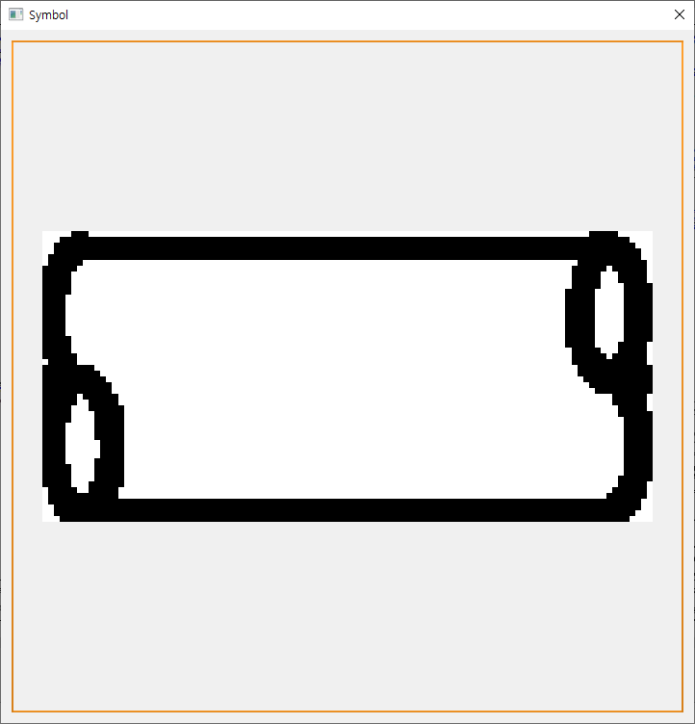

* Delete Symbol: Delete the selected symbol.

## Add symbol Attribute

* In the right [Symbol Explorer], right-click on the symbolic type and then click [Edit Attribute].
  + [+] Press the button to add a new attribute.
    - Name: The name of the attribute
    - Display Name: Name to be seen
    - Type: Item type with corresponding attributes of symbol
      * Combined: Create a new attribute by combining registered symbol attributes.
    - Attr. At: The number of items to fill the attribute
      * String, int type, omitted.
    - Expression: A format that actually gets the value from the item to fit in the attribute
      * Follow Python grammar.
      * String, Int type omitted.
      * If Combined type, enter the attribute name in braces ({attribute name}).
    - Target: Set the symbol to which the attribute will be applied.
      * For ALL, it applies to all symbols of the selected type.
      * Double-click to set the application of individual symbols.

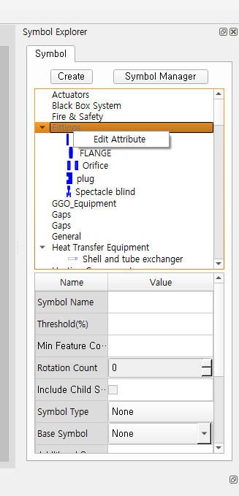

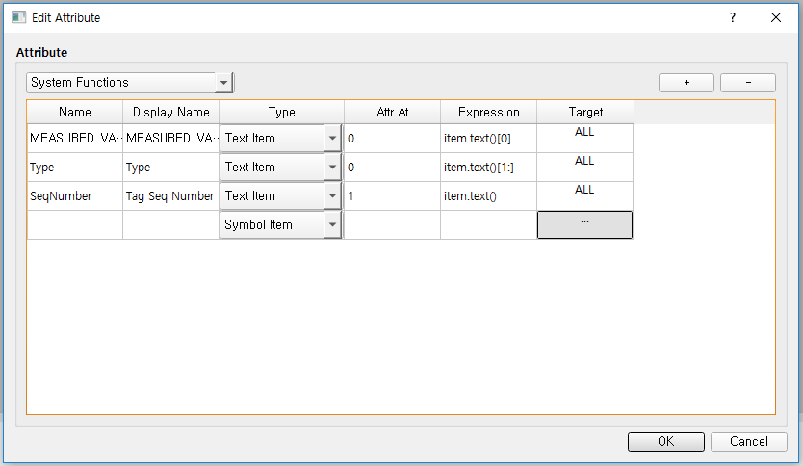

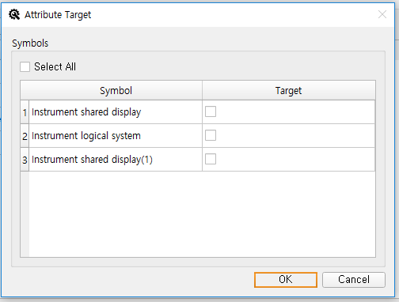

## Symbol Manager

The created symbols can be reused in other projects through the export/import feature.   
The symbol library import feature can only be run early in the project.   
(After you've done symbol recognition on a drawing, you can't run the symbol library import feature.)

* On the right side of [Symbol Explorer], click [Symbol Manager].

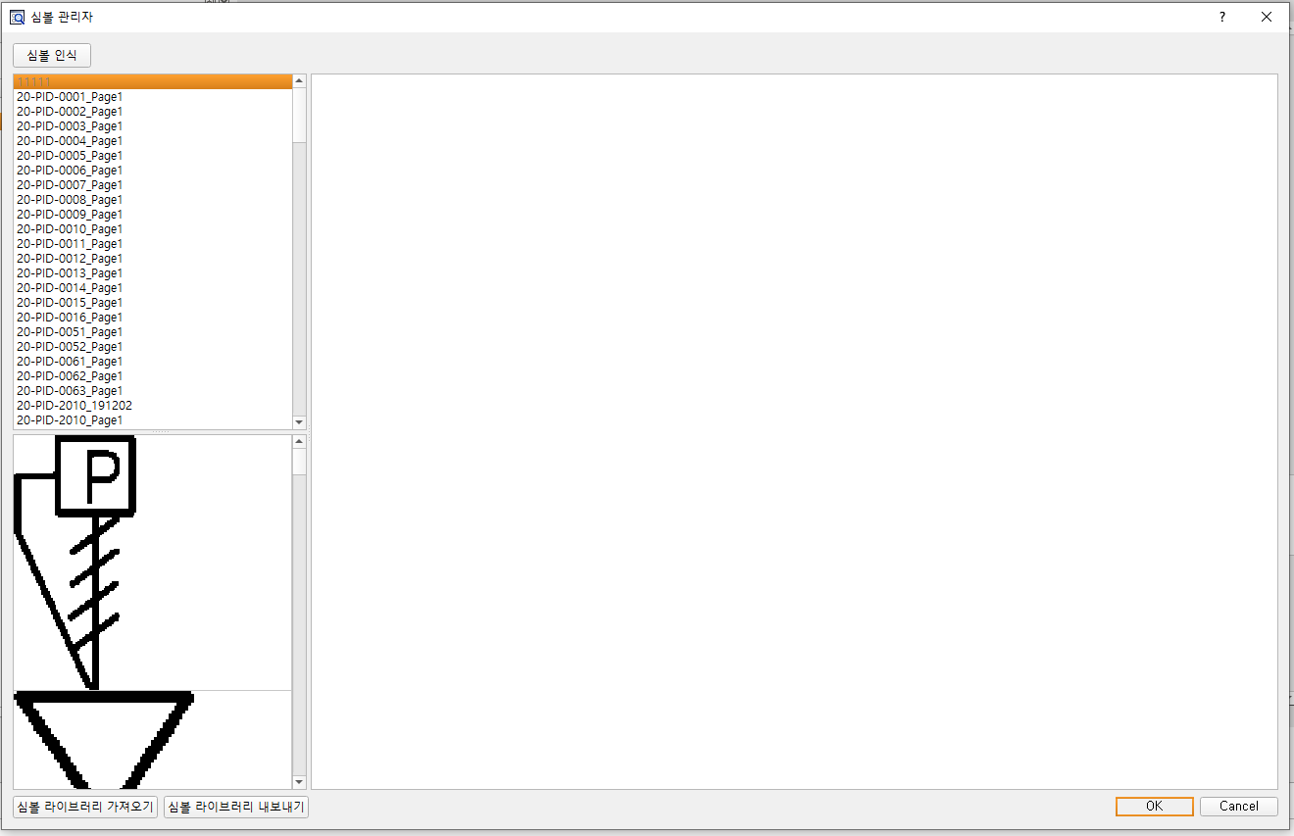

* + Get a symbol library
    - In the file selection window, select the library of symbols to import. (Extension: . syl)  
      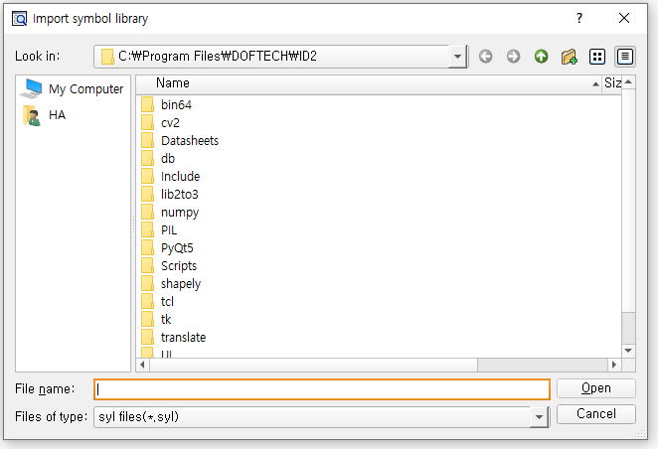
    - When the symbol library import is complete, a confirmation window appears.
  + Export symbol library
    - Set the location and name of the symbol library to be created in the file selection window.  
      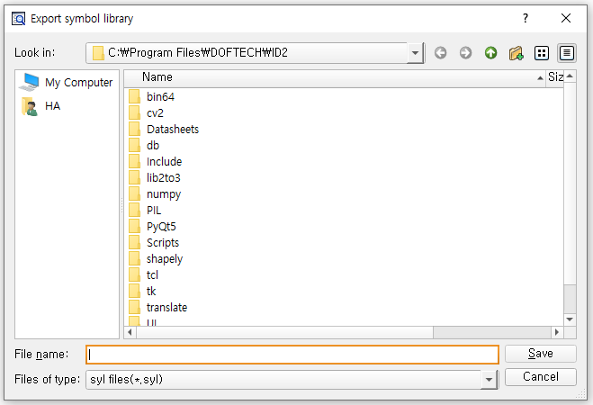
    - When the symbol library is exported, a confirmation window appears.
  + Copies the [Image], [Svg] folders in the existing project folder to the new project folder when you later load an existing symbol in a new project.

# Recognize

## Character recognition

* Click the icon at the top of the center and drag the characters in the drawing.

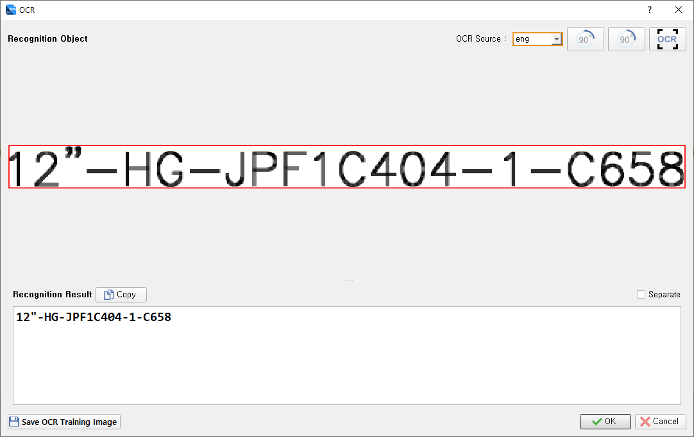

* + For rotated text (if the angle of the text is not zero), you must use the Rotate button at the top to zero the text and proceed with text recognition.
  +  : Rotate the image to the left.
  +  : Rotate the image to the right.
  + : Use OCR in the image to recognize the text.
  + Save OCR Learning Images: Save selected images as learning images so you can use them to generate OCR learning data.
  + OCR Source: Set the OCR data to be used for text detection.
  + Recognition Result Copy: Copy the recognized result text to the clipboard.
  + Separate: When you select a check box, separate the text that is recognized as multiple lines and create each. If unchecked, create a single text object.
  + Save OCR Training Image: Save as an OCR learning image file.

## Drawing recognition

* +   icon allows you to recognize multiple drawings by clicking on the currently open drawing or by clicking [Object Explorer] – [Drawing List] – [Placement Tasks].
  + Design information recognition: [symbol], [text], [[line] recognition or not, then click [Information Recognition] to recognize the design information.   
    - Learning data generation: Create symbolic data for AI learning at check

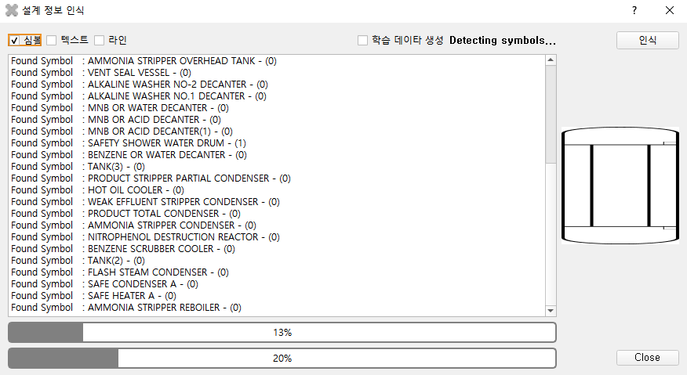

* + Object Explorer: You can see the recognized information.

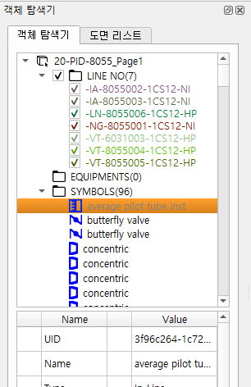

* + - When you select an object, the attribute window shows the attribute of the object and you can move it to that object.
    - For Line No, you can set From, To in the Properties pane. From, To is used to configure Line No Topology in property links.

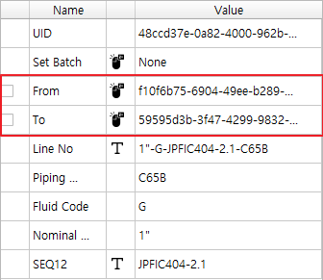

You can double-click on the mouse-shaped area to specify the From or To object on the Canvas.

* + - Pinning symbol properties: Checking the box in front of the Name column will not be modified when linking properties or editing manuals.

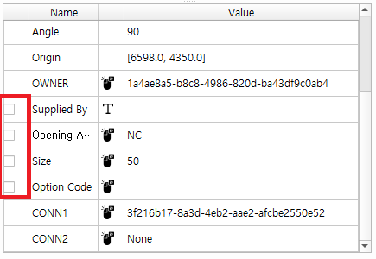

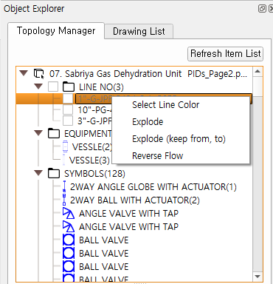

* + - Line No Color Settings: You can right-click to set the color for each Line No.

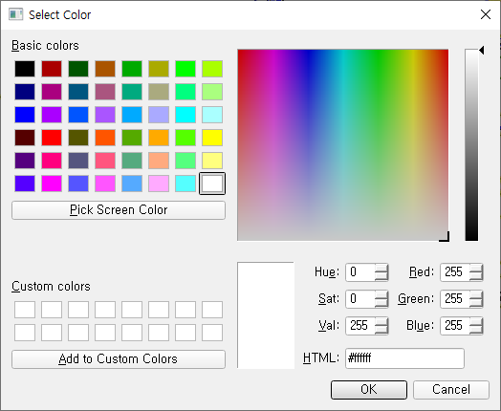

Figure Select Line Color

* + - Explode: Turn off The Line No Topology configured.
    - Explode (KEEP From, To): Turns off the configured Line No Topology, but keeps the Line From, To.
    - Reverse Flow: Changes the flow direction of the line that forms Line No.

To change the orientation of some lines, select the line and press the "c" key to change the direction of that line.

## Modifying recognition results

* Correct misrecognition and omission after drawing recognition.
  + : Initialization > Delete all recognition results (non-recoverable).
  + : Select line > line type and draw a line (short key: L).

- Draw from the connection point of the device, symbol, and line object to end with the connection point of the device, symbol, and line object.

* + : OCR > Recognize text. ((Short key: T)

- If you specify the range of text to be recognized on the canvas, a text detection screen appears.

* + : Set up vendor package area.   
    - If you specify a vendor patch area on the canvas, the value set by the user (default: 'By Vendor')) is automatically set by supplied By, one of the object properties, to target objects such as valves and relays within the area whenlinking properties.   
    When creating the package, press the 'i' button to add a new node after the selected node, and press the 'd' button to delete the selected node.
  + 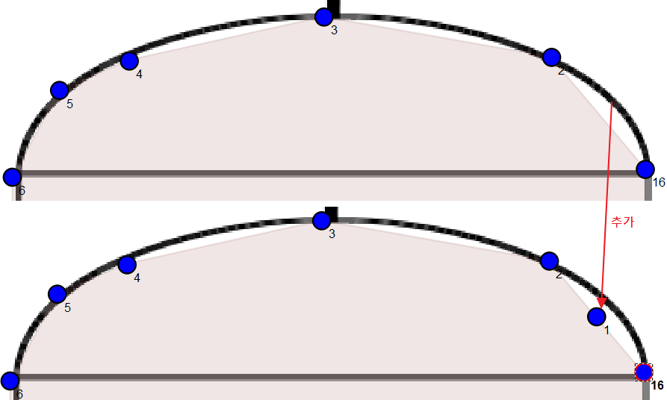
  + : Set up a virtual device area..   
    - You can connect the nozzle to the generated device area to treat it like a device.

- Select the device area you created and click the [Symbol Explorer] – [Create] function to automatically extract the selected image, register it as an instrument symbol, and place it automatically.

* + : validation > validation check

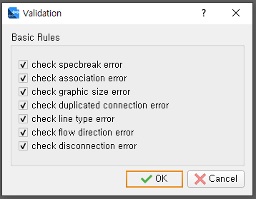

* + - Basic Rules: You can check the validation items.
    - [OK] Press the button to perform validation.
      * Check the validation results in the bottom Inconsistency table.
      * When you click Owner, you'll be taken to that item on the canvas.  
        

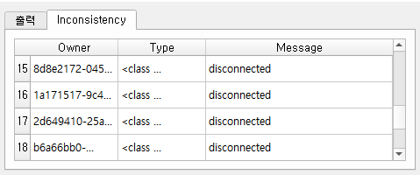

* + Global Validation
    - [Data]-[Global Validation] Click on the menu.
    - When you enter a symbol attribute name, it checks the duplicate values for the entire drawing.

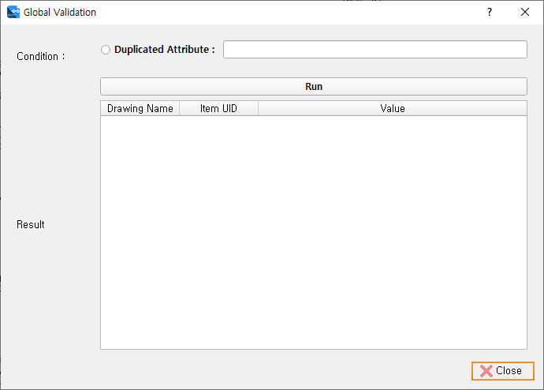

* + : Rotate > Click on this icon after selecting a symbol to rotate in 90 degrees. (Short key: R))
  + : Zoom > After selecting this icon, the specified area will be enlarged. ((Short key: Z))
  + : Fit > shows the entire drawing.
  + : Line color changes by object type such as line, symbol, etc. or by line No group.
  + Symbol Position: After selecting the symbol to move, you can set the position of the symbol by pressing Enter.   
    ((Short key: double-click mouse left, directional key)

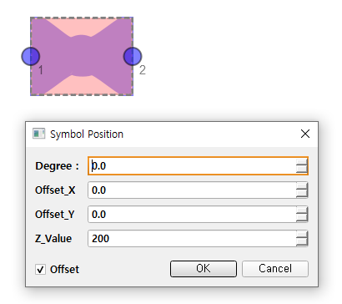

* + Symbol Connection: Click the symbol you want to connect to and press the "B" key. Automatically connect to adjacent lines and symbols.

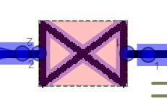 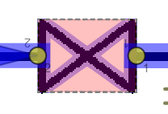

* + Symbol Insertion: Select a symbol from symbol explorer and then press **"I"** from the desired position on “the drawing. If you replace a symbol, click the corresponding symbol in the drawing and press Ito replace it with the symbolof choice.

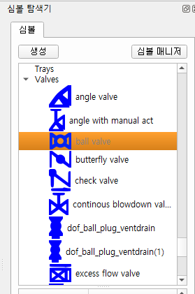 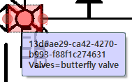 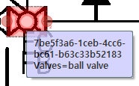

## Attribute link

* Click this icon to link recognized lines with line numbers, symbols, and properties and to configure Line No Topology.
  + Flow mark update: Update the flow mark of the lines at check
  + Segment Break Update: Update the segment brakeaccordingly to the line group at check.
  + Line type renewal: Update the line type according to the conditions set at check-in. (Recommended oncefor thefirst time)
  + Close validation with Check: When you check and click the Close button, the results are displayed in the output window after validation.

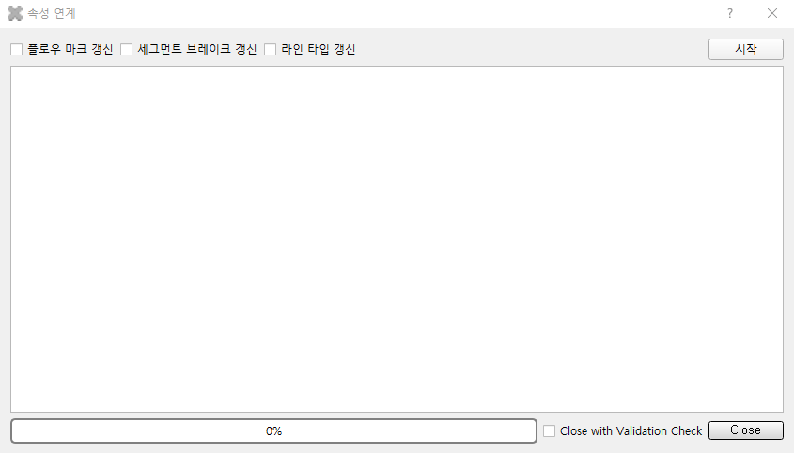

* + Find special items adjacent to the line and connect the lines with the Special Items.
  + Line No Topology, configured in attribute link is displayed in the tree.

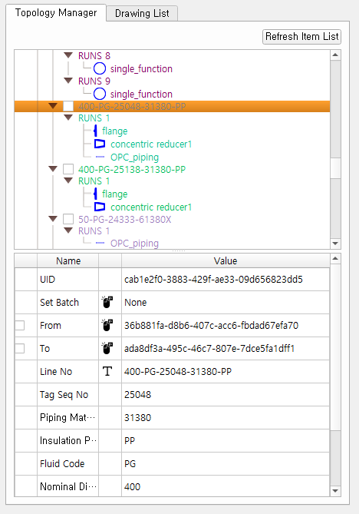

* + - From, To: Item UID of line number From, To is displayed and can be modified with double click.
    - The attributes of the line number are displayed.
    - In the tree, the topology edit menu appears when [right-click].

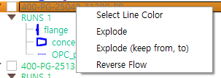

* + - * Explode: Release From, To info and Run and items assigned to the line number.
      * Explode (keep from, to): From, To turn off except for information.
      * Reverse Flow: Reverses the fluid orientation of Run.
* Spec Break: Change the properties of pipe Line.
  + Register the Spec Breakused in the projectas a symbol.
  + When linking attributes, aregistered Spec Break is automatically created based on the attributes of the line number.

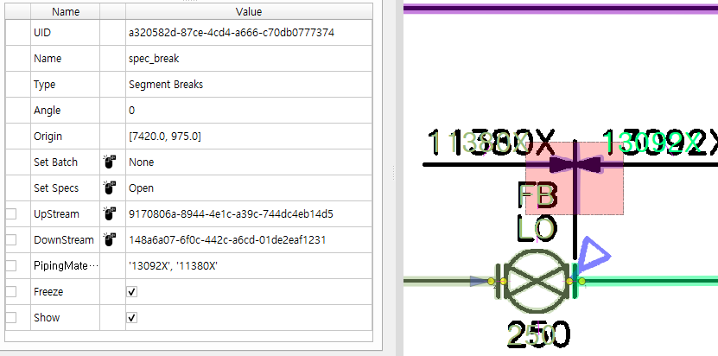

* + You can check the details by selecting the generated Spec break.
    - Upstream, Downstream: The UID of the left and right items divided by the specifications are displayed.
    - Next, the attributes divided by the Spec break are listed.
    - Freeze: If you select the Value column, it will be fixed non-renewable at the next attribute link.
    - Show: Select the Value column to insert a graphic symbol when converting to Intelligent P&ID.
    - Set Specs: Edit the attributes that the Spec break divides.
      * [+] Add an attribute with a button and then select a property to divide.
      * Set the value of the Upstream item and the value of the Downstream item.

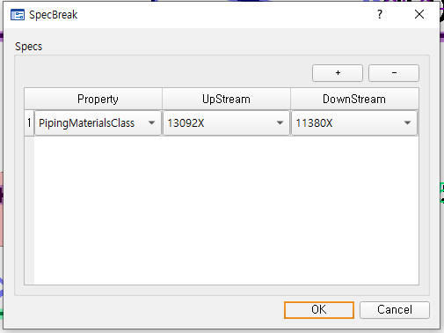

* End Break: Separate different line numbers.
  + Register the End Breakused in the project asa symbol.
  + When linking attributes, an End Breakregistered based on the line number is automatically generated.

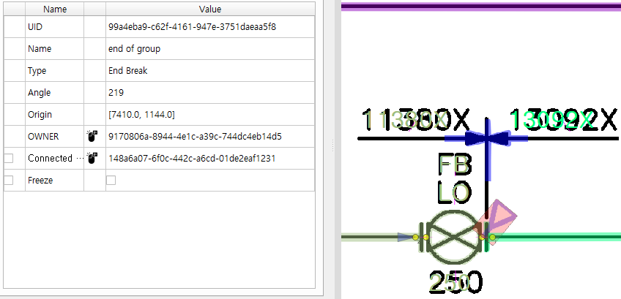

* + You can check the details by selecting the generated End Break.
    - OWNER: The UID of an item with End Break is displayed.
    - Connected Item: The UID of the linked item isdisplayed.
    - Freeze: When you select the Value column, it is fixed without being renewed at the next attribute link.

## Find/replace

* Click [Edit] –[Find/Replace] menu.

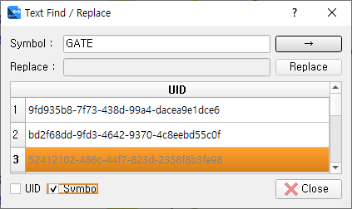

* + You can find or replace text.
  + If you have a large number of search items, they are displayed in the table below.
  + Enter the symbol type, check the symbol box, and click the [->] button to display the symbols of that type in the table below.   
    When you click a table item, you go to that symbol.
  + Enter the UID of the symbol, check the UID box, and click the -> button to go to that symbol.

## Text Data List

* Click [Edit] – [Text Data List] menu.

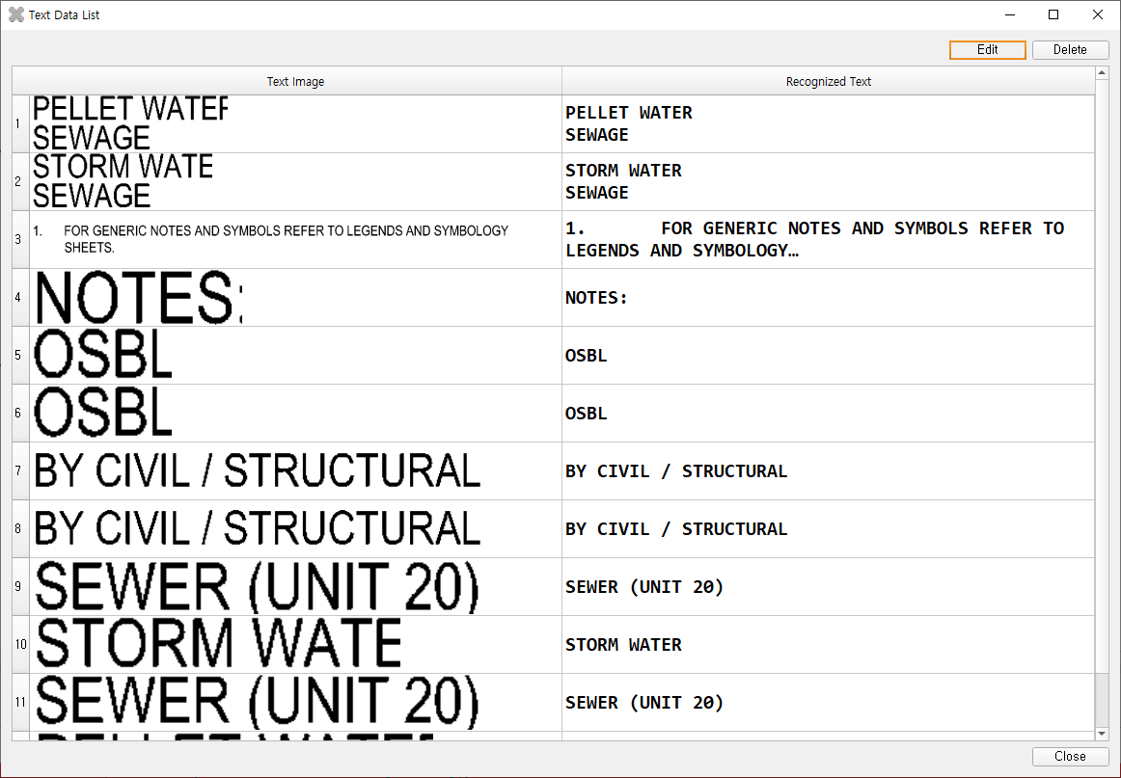

* + You can see the text releases that are currently recognized in the open drawing.
  + When you click the list, you go to that text.
  + Select the text and click the Edit button to open a window where you can edit the text.

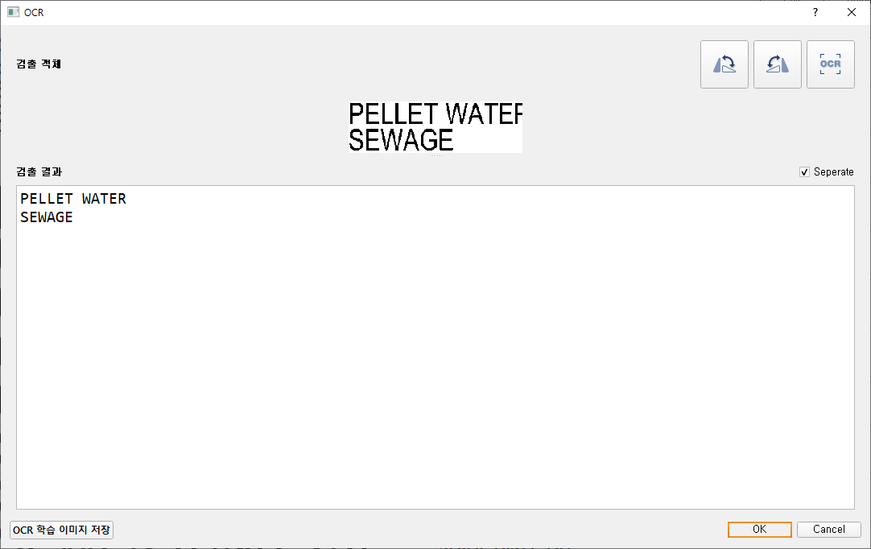

* + - You can modify the recognized text. – [2.9] See
  + Delete: Delete the selected text.

## Replace or Insert Symbol

* Click [Edit] – [Symbol Replace/Insert] menu.

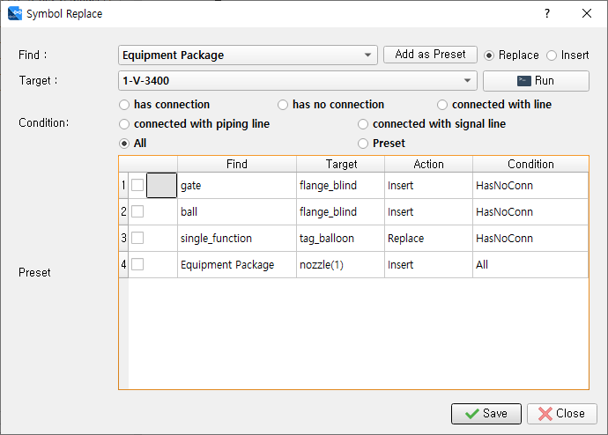

* You can replace or insert symbols that match the conditions.
* Symbol replacement: The symbol that meets the condition is replaced with another symbol.
* Select Replace.
* Find: Select the symbol to be replaced.
* Target: Select the symbol to be replaced.
* Condition
  + has connection: Replace if there is a connected symbol or line
  + has no connection: replace if there is no connected symbol or line
  + connected with Line: Replace if connected with piping or signal line
  + connected with piping line: Replace if connected with piping line
  + connected with signal line: replace if connected with signal line
  + All: Replace all symbols set in Find
* Execute the replacement by pressing the [Run] button.
* Symbol Insert: Inserts a new symbol at the connection point of the symbol that meets the conditions.
  + Select Insert.
  + Find: Select the symbol to be inserted into.
  + Target: Select the symbol to be inserted.
  + Condition:
    - has connection: Inserted at a connection point with a connected symbol or line
    - has no connection: inserted at a connection point without a connected symbol or line
    - connected with Line: Inserted into the connection point connected to the piping or signal line
    - connected with piping line: inserted into the connection point connected to the piping line
    - connected with signal line: inserted at the connection point connected to the signal line
    - All: Insert at all connection points of symbol set in Find
  + Click the [Run] button to execute symbol insertion.
    - Add as Preset: Saves commands to be performed automatically.
    - After setting the conditions to use the Replace and Insert commands, click the [Add as Preset] button.
    - The set condition is added to the Preset table.
    - The added preset is automatically executed after drawing recognition.
    - To execute a saved preset in an individual drawing, select the preset from Condition, click the check box of the preset to be executed, and click the [Run] button
  + Example
    - In the case of Preset 1 in the upper image, if the connection point of the gate symbol is not connected, insert the flange_blind ball.
    - No. 3: If there is no other item connected to the single_fuction symbol, replace it with tag_balloon.
    - No. 4: In the case of Equipment Package in Find, the symbols registered as devices and the area drawn with the Equipment Package function are all covered. Insert the device symbol in the drawing or the nozzle(1) symbol between the adjacent line and the device in the drawn device area.

## OPC Relation

* Click [Data] - [OPC Relation] menu.

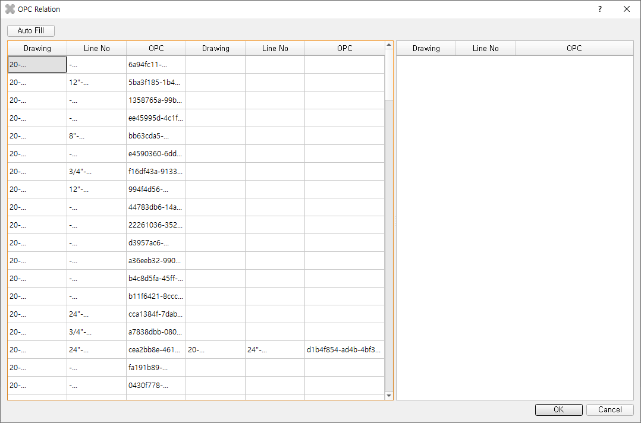

* + You'll see a list of all OPC created in the project.
  + Auto Fill: Automatically links OPC relationships when they are clear based on Line No.
  + The OPC list on the left shows the connection between OPC and OPC.
  + Clicking on the left OPC list displays the OPC list with the same line number in the right OPC list.
  + Double-click in the OPC list to link OPC.

## Streamline settings

* Click the button on the toolbar.

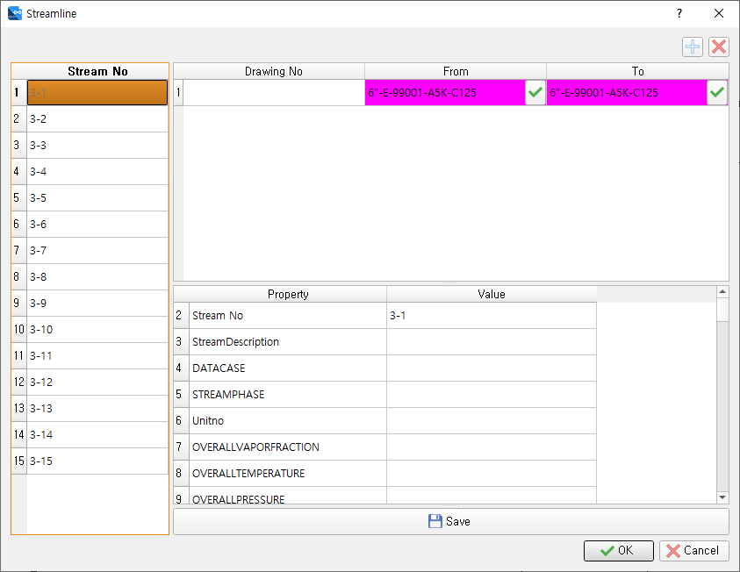

* From: Click From item to select Stream No from on the canvas.
* To: Click on the To item to select Stream No's To Stream No on the canvas.

# Report

## Design information list

Automatically extracts data from recognized design information, and you can generate line lists, instrument lists, valve lists, equipment lists, note lists, and Special item lists as Excel files.

* Click [Data] - [Design Information List] menu.

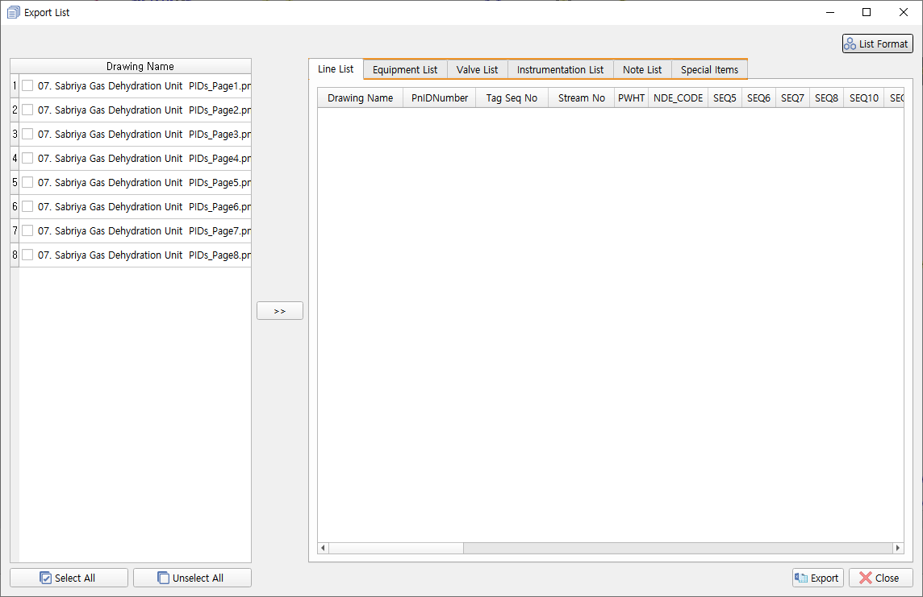

* Select the drawings to look up from the "Drawing name" list.
  + Select All: Select all the drawings.
  + Unselect All: Deselect selected drawings.

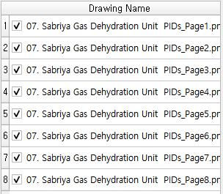

* to view the design information in the selected drawing.  
  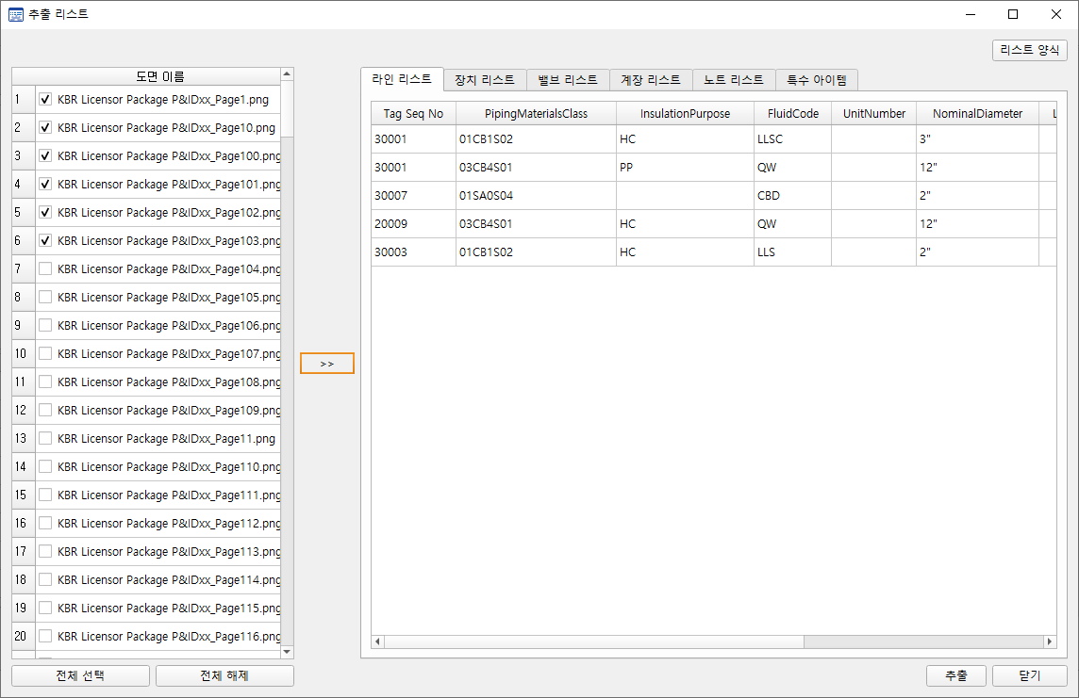
  + - Line list
      * Displays line No Attributes.
    - List of Equipment
    - List of Valve
    - List of instrument
    - List of notes
      * Displays the note number and description.
    - List of Special Item
      * Displays O,X for the existence of special items for each Line No.

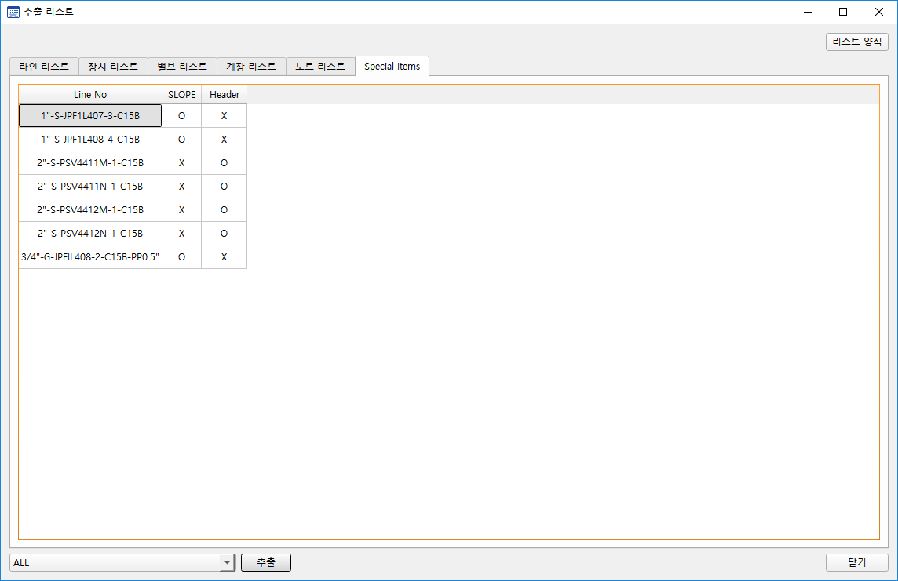

* Click [Item Data Format]]
  + Set the list extraction form: Set the form to be extracted by Excel for, lines, Equipment, valves, instrument, and note lists.

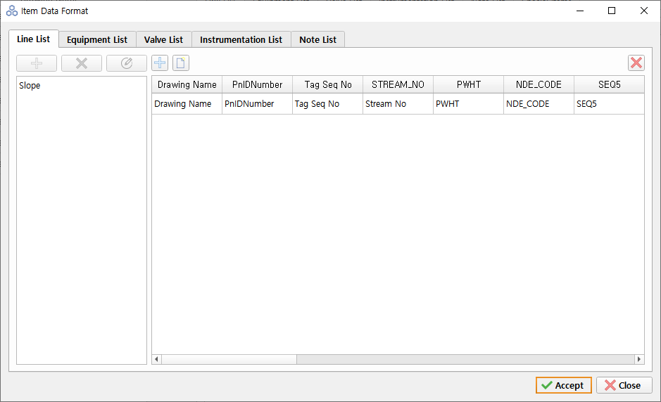

* + - Add attributes: You can drag and drop attributes from the left list box to add them to the right grid or click the Add attributes button to add them.
    - Add an empty column: Add a new column that is empty.
    - Delete column: Delete the selected column. Deleted columns are added to the left list box.
    - You can change the order by dragging and dropping columns in the grid.
  + List output: Click [Extract] to extract data from a set form.

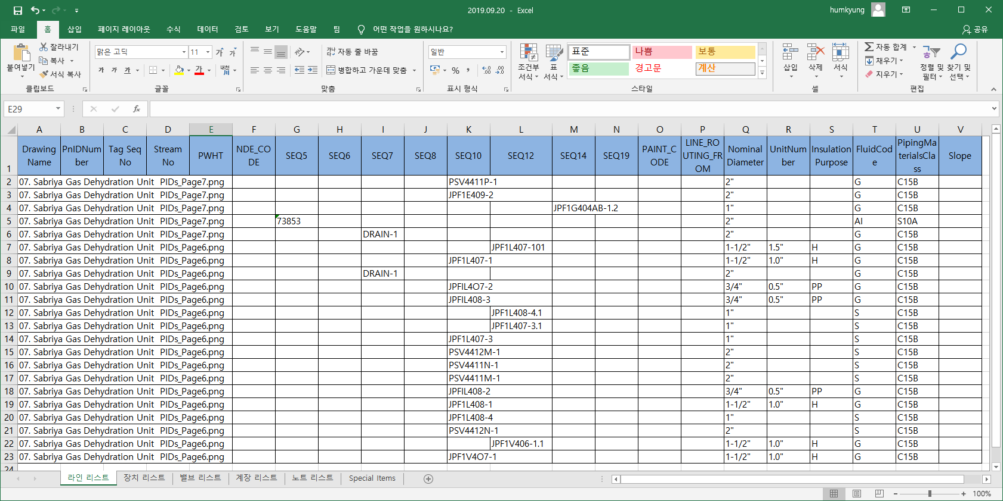

# View

* You can turn certain objects on and off on the screen by selecting image drawings, text, symbol, line, unrecognized, inconsistencies, and vendor areas.
  + The item's parenthesis can operate with a key of 7.

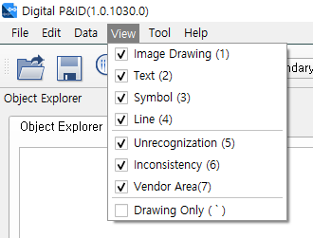

* + The screen below is when the line is selected.

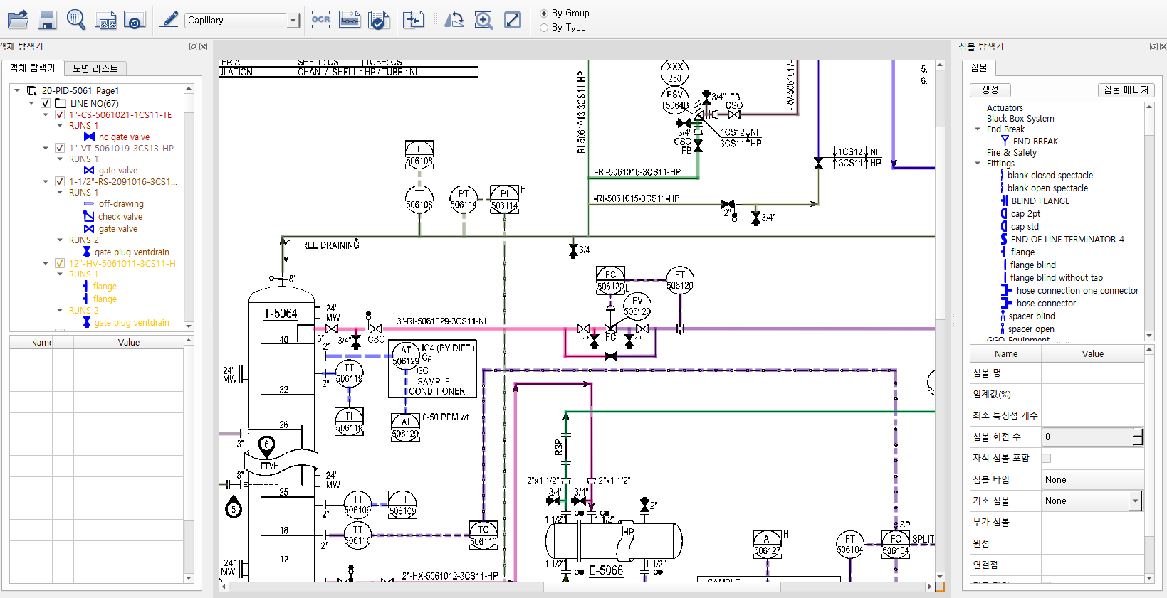

* + [Toolbar] – By Group
    - Pipe lines and symbols belonging to the line are displayed on the screen according to the Line No Color set in the environment setting
  + [Toolbar] – By Type
    - Each recognized object is displayed on the screen according to the symbol style set in the environment setting.

# Convert PDF

* Click [Tool] – [Convert PDF] menu

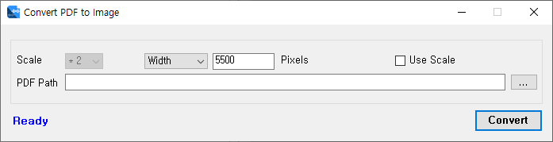

* + Scale: Multiple size of the image to convert (Use Scale should be checked and applied)
  + Width: The size of the drawing to be converted
  + PDF Path: Folder containing PDF files to convert
  + Recommended size: Convert from PDF of A3 size to 7-9 scale. All PNG files must be the same size. (Final Image PNG File Resolution: Approximately 9000 X 6000 pixels).
  + If the PDF contains text, the text is saved as a file with the same name (extension .xml).
  + If the size of the image to be converted is too large, you can attempt to convert again by reducing the Size of Scale or in the event of a memory error.

# Importing data (lines, text)) from CAD

* Click [Tool] - [Import Data from CAD] menu

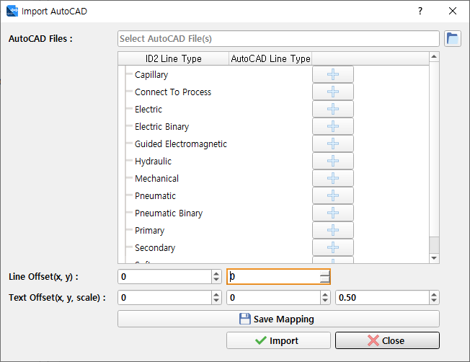

* + Select the AutoCAD file that extracted the text.
  + Set up AutoCAD Line Type to convert to ID2 Line Type.
  + If you need to calibrate the line position after conversion, enter the Line Offset information.
  + Enter Text Offset and Scale if you need to calibrate the position and size of the text after the conversion.
  + [Save Mapping] Press the button to save the value you set.
  + [Import] Press the button to extract lines and text from the selected AutoCAD file and save it to ID2.
  + [Edit]-[Connect between symbols and lines] Click the menu to connect symbols and lines to each other.

# Importing text from PDF (Instrument extension)

* + Click [Tool] – [Import Text from PDF for Instrument] menu

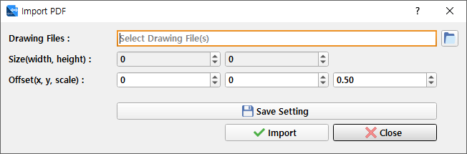

* + Select the ID2 drawing where you want to enter text.
  + Set the size of the text to be applied when reflected in the ID2 drawing.
  + Enter Offset and Scale if you need to calibrate the text position and size after the conversion.
  + [Save Setting] Press the button to save the value you set.
  + [Import] Press the button to read the text extracted from the PDF file and reflect it in the ID2 drawing.

# Enhanced symbol thickness

* Click [Tool] - [Enhanced symbol thickness] menu.

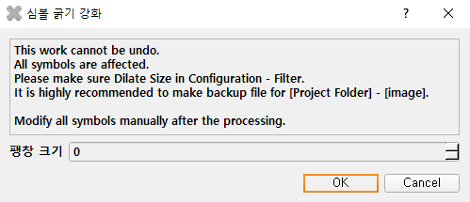

* + Expansion Size: Strengthens the thickness of all symbols registered with set values.

# Data Migration

* Click [Tool] - [Data Migration] menu. Data from SQLite can be migrated to MSSQL.

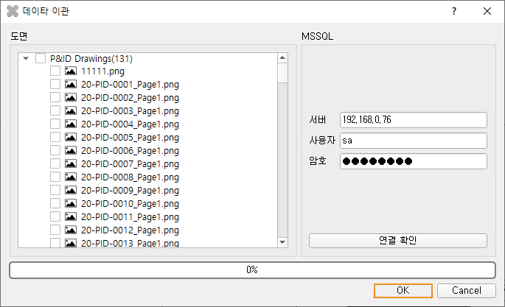

* + Enter the MSSQL connection information to verify the connection.
  + In the left tree, select a drawing to transfer the data, and then press the OK button to transfer the data to MSSQL.

# Export

* Click [Tool] –[Export] menu. To convert to a commercial P&ID, you can generate design information from the database as an XML file.

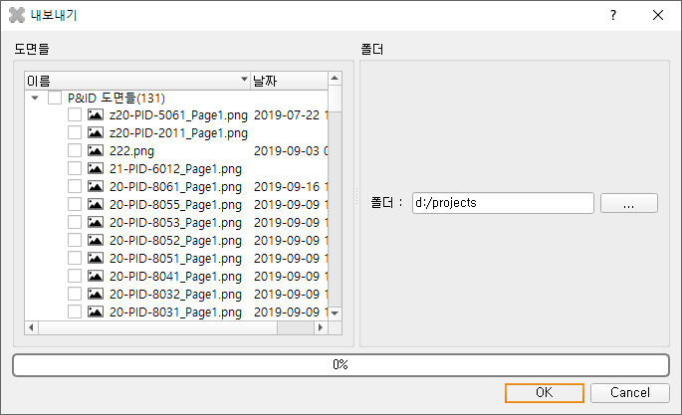

* + Select the drawings you want to create with XML
  + Select the folder where XML files will be stored
  + [OK] Press the button to create XML files

# Troubleshooting procedures

* PNG files differ in size after conversion (Drawing size or accumulation in original PDF file)
  + Change all drawing sizes in the original PDF to PNG.  
    (e.g., convert all PDFs to A3 paper and then from ID2 to 7-9 scale about 9000 X 6000 pixels size)
* Different shapes and sizes between the same symbols
  + Register multiple symbols with the same name and property for each shape and size.   
    When you create a symbol with the same name, a number is automatically generated after the name.   
    (The more symbols you register, the longer the recognition time. )
* Title block shape, size vary by P&ID drawing
  + The title block is grouped between the same drawings (the recognition area is the same), so that the group-specific drawing range isadjustedand then spread out to proceed with the recognition.
* Text is not recognized in the drawing
  + 2.3 Preferences - Change the minimum Text size to a smaller value by referencing the text detection item.