Fire Fighting CAD Drawing Importing

Cad drafting, Importing GUIDE

2023

INDEX

1. CAD Importing Module 2

2. AutoCAD Drawing Rules: Pre-Work in AutoCAD 3

3. AutoCAD Line and Symbol Block Legend: Pre-Work in AutoCAD 6

4. ID2 Project Setup: Pre-Work in ID2 Project 8

5. AutoCAD Import Dialog: Import Module Features 9

6. CAD Symbol Block Legend Import: ID2 Project Setting 11

7. CAD Layer, Block Mapping: ID2 Project Setting 13

8. Importing CAD Drawings: ID2 Drawing Work 14

9. ID2 Touch-Up: ID2 Drawing Work 15

10. SP P&ID Line Condition Input Feature: Pre-Work in SPPID Converter 16

11. SP P&ID Converting: SPPID Drawing Work 18

12. SP P&ID Touch-Up: SPPID Drawing Work 19

# CAD Importing Module

The ID2 CAD Importing Module generates intelligent drawings by importing AutoCAD (*.dwg) drawings into ID2.

1. Click the [Tool] - [Import AutoCAD] button at the top of the main UI to run the module. *- Figure 1*
2. Import symbols, text, and lines from the AutoCAD drawing that was created according to the rules defined below.

When creating a drawing in AutoCAD, symbols must be used as block references and lines must be drawn on layers distinguished by type. (For detailed rules, see "2. AutoCAD Drawing Rules".)

1. The CAD importing process includes creating an AutoCAD symbol block legend, creating an AutoCAD drawing, importing an AutoCAD symbol block legend (creating ID2 symbols), mapping AutoCAD information, importing the AutoCAD drawing, and performing ID2 drawing correction
2. This document is composed of the following sections.
   1. Preparations for AutoCAD Drawing Creation (Chapters 2 and 3)
   2. ID2 Project Preparations (Chapter 4)
   3. Explanation of ID2 AutoCAD Import Module Functions (Chapter 5)
   4. ID2 Project Settings for AutoCAD Import (Chapters 6 and 7)
   5. ID2 Operations for Creating ID2 Drawings from AutoCAD Drawings (Chapters 8 and 9)
   6. Converter Preparations for Inputting Line Condition (Chapter 10)
   7. SPPID Operations for Creating SP P&ID Drawings from ID2 Drawings (Chapters 11 and 12)

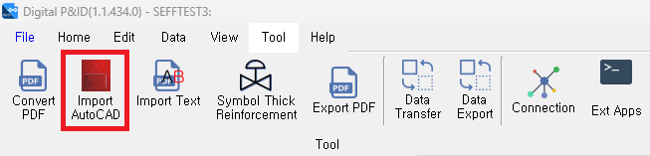

Figure : ID2 CAD Importing Module Button Location

# AutoCAD Drawing Rules: Pre-Work in AutoCAD

AutoCAD drawings are drafted according to the rules to facilitate ID2 import and SPPID conversion.

AutoCAD drawings that do not follow these rules may result in missing items or reduced accuracy during ID2 import, and the affected items will need to be manually corrected in ID2.

1. General
   1. AutoCAD units are in mm.
   2. AutoCAD grids are drawn to fit the grid using 1.27mm.
   3. Symbol Blocks, Pipe Lines, and Signal Lines are drawn with a minimum of 1 grid. (2 grids or more recommended)
   4. AutoCAD drawings should only be drawn within the Border Template. (including Legend)
   5. Place the lower left corner of the Border Template at 0,0.
   6. Use the same shape for the Border in AutoCAD and the Border Template in SPPID.
   7. If a block is a library, not a single symbol, set the block name as “Piping”+Name. (Ex. Piping+HIA-N234)
2. Line
   1. Use layers based on the type of the line. (Ex. Primary, Secondary, Electric, Software, Connect to Process, etc.) *– Figure 2*

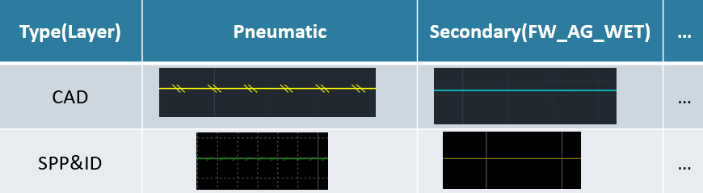

Figure : AutoCAD Line Layer and SPPID Line Type

* 1. Vertical and horizontal lines can be used, and diagonal lines can be used at 45-degree intervals. (Ex. 0, 45, 90, 135, 180, ...)
  2. Curved lines should be avoided as they cannot be transformed. (Ex. AutoCAD Ellipse Command)
  3. If the line is part of a block, draw the line on the same layer of line drawn outside.
  4. If the line needs to branch in SPPID, separate the line in AutoCAD as well. *– Figure 3, Line 2, 3*
  5. When three lines meet, draw the length of the main line longer than the branch line. (if necessary, divide the branch line) - *Figure 3, Line 1 and 2, 3*

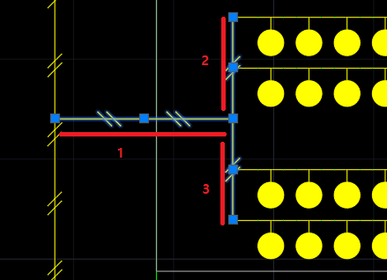

Figure : AutoCAD Line Branch

1. Symbol
   1. Use the AutoCAD block that corresponds 1:1 to the SPPID symbol.
   2. The unit symbol block should not include other blocks inside. (If the shape is the same, explode and save)
   3. If the same shape in AutoCAD is converted into a different symbol in SPPID, use a different block. *– Figure 4*

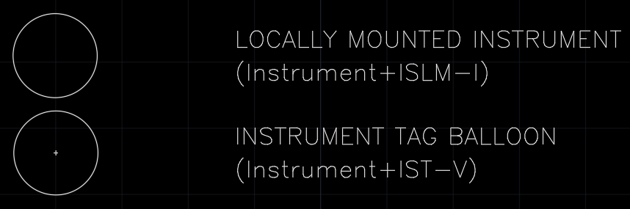

Figure : Same Shape Symbol

* 1. Set the position of the INSBASE(0,0) of the symbol block to match the origin of the SPPID symbol.
  2. Insert connection points of the SPPID symbol into the AutoCAD symbol block as a Point.

The order of creation of Points follows ID2 rules. (left-right-bottom-top)

* 1. Set the 0-degree shape of the SPPID symbol and the AutoCAD symbol block to match.
  2. AutoCAD Symbol Block Name is set to “ID2 Category”+Symbol Name (Ex. Valves+Gate Valve) (The Category list is “13. ID2 Symbol Category”)
  3. Graphic Conversion Block Name is set to “Graphic”+Name. (Ex. Graphic+Detail WsNozzle)

1. Text
   1. Text located inside a Block that is converted to a Graphic must use only fonts supported by SmartSketch. (Ex. romans, arial, etc.)
   2. Label Text should be positioned as close as possible to the corresponding Symbol or Line. (Ex. Line No., Equipment Tag, Size, etc.) *- Figure 5*

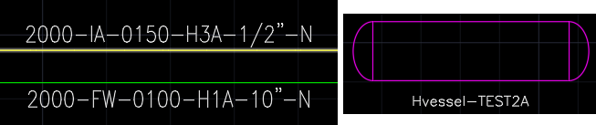

Figure : Label Text

* 1. Text included in the SPPID Border Template by default should not be included in the AutoCAD drawing. (Ex. Project Name, Drawing No. etc.)

# AutoCAD Line and Symbol Block Legend: Pre-Work in AutoCAD

Create a legend for all lines and symbols used in creating AutoCAD drawings.

Use these lines and symbols to create a AutoCAD Block Library and generate AutoCAD drawings.

And import the legend into ID2 to create and map ID2 Symbols.

1. Arrange the symbols at 0 degree.
2. Sort the lines used in the drawing (Piping, Signal) by layer.

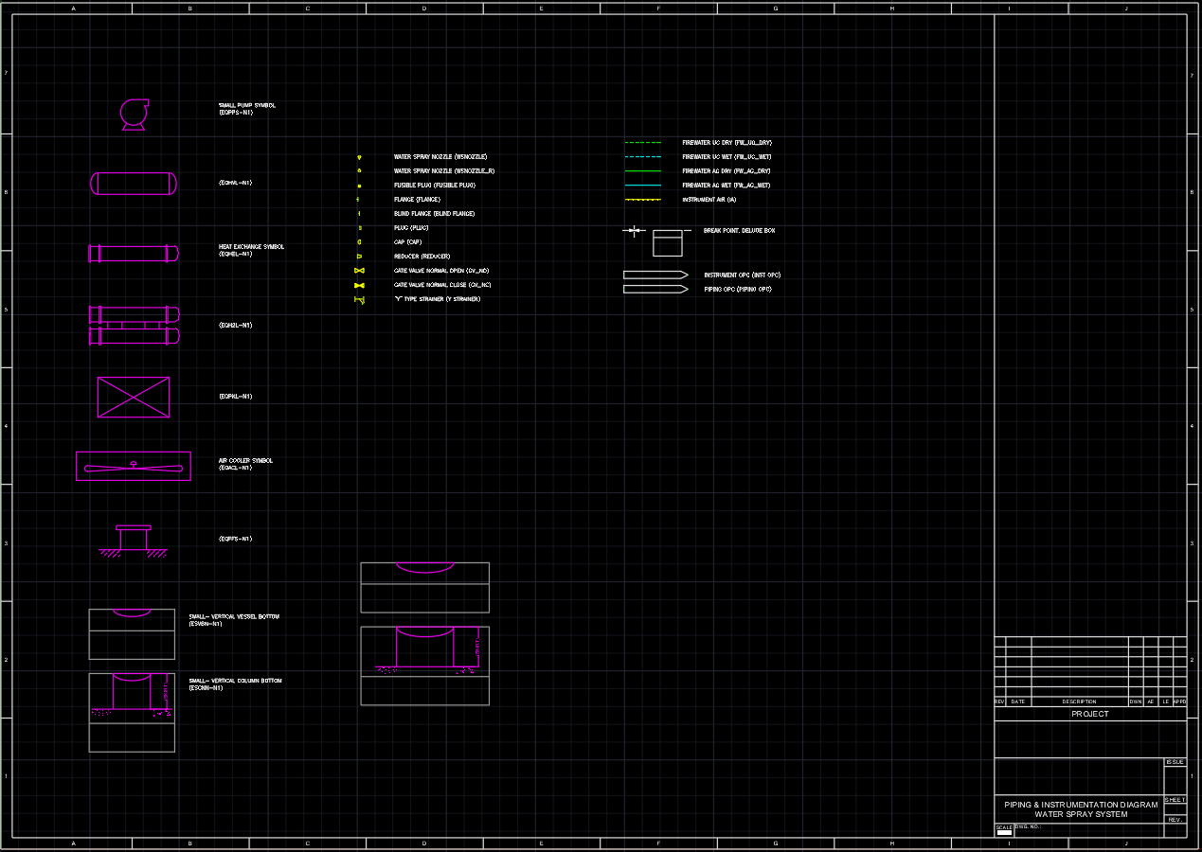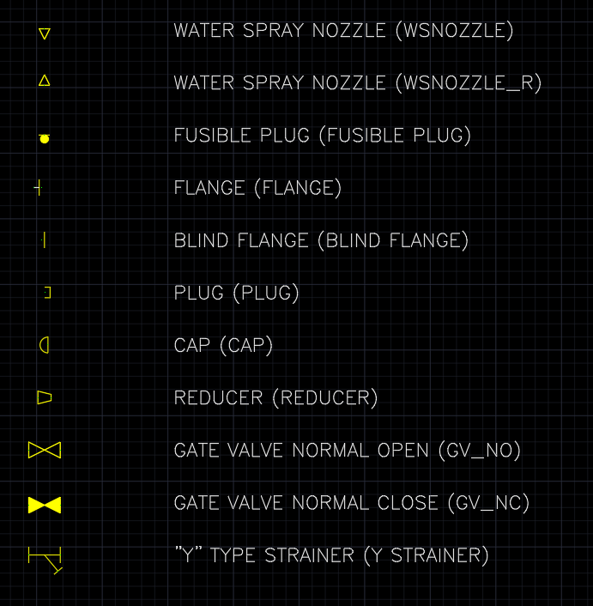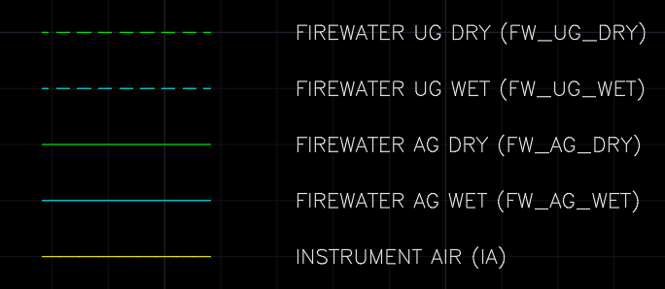

Figure 6: AutoCAD Block Legend

1. Draw all AutoCAD drawings and Block Libraries using only the Blocks defined in the legend.
   1. Block Library: Blocks created using Symbols defined in the legend are used in the CAD drawing automation program.

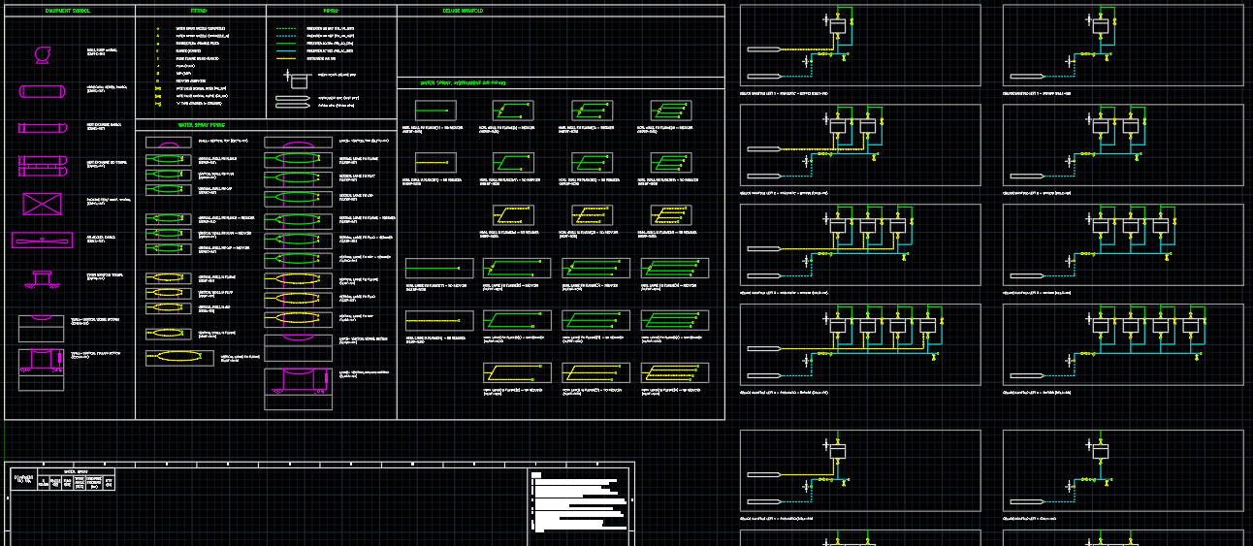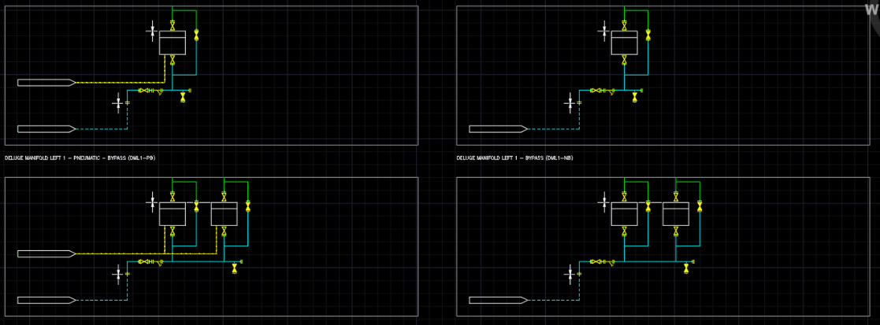

Figure 7: AutoCAD Block Library

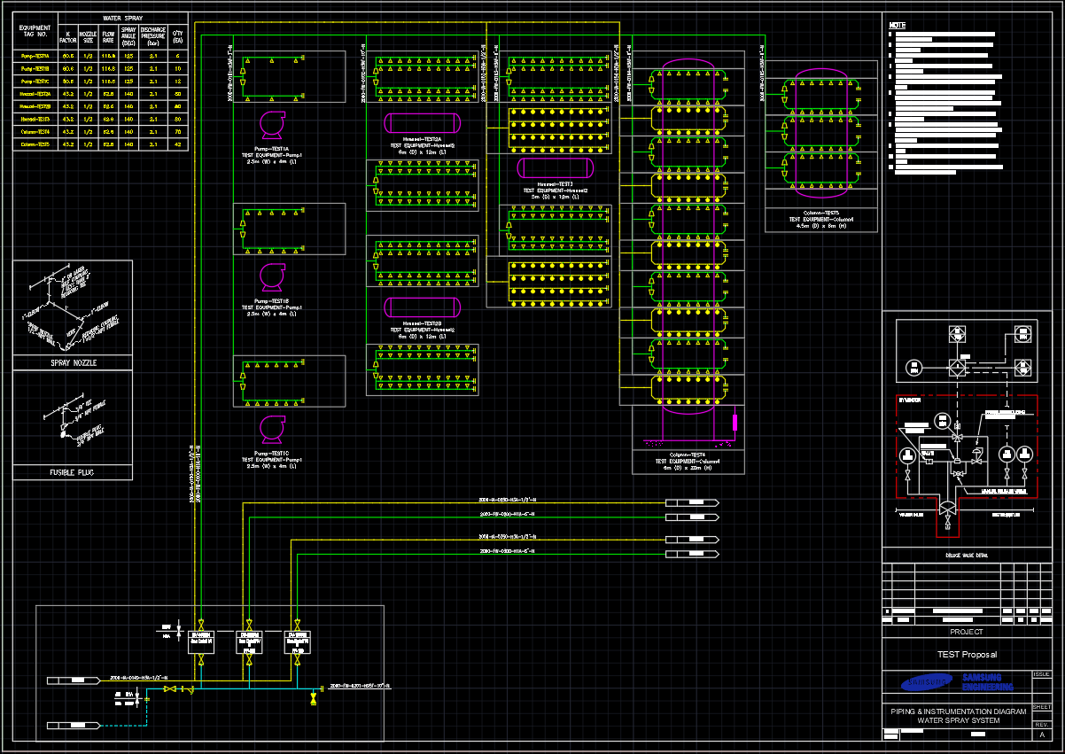

Figure 8: AutoCAD Drawing

# ID2 Project Setup: Pre-Work in ID2 Project

1. After running ID2, select or create a project, then change the [Project Mode].

Each mode has defined functions and themes, which can be changed in settings after execution.

1. Place the AutoCAD drawings to be imported in **drawings\Native** of the ID2 Project folder.
2. SmartSketch must be installed to convert Graphic Blocks. (No License Required) – *Figure 10*
   1. Install SmartSketch.
   2. Copy the Dwg2Igr.exe file from the ID2 installation folder.

(C:\Program Files\DOFTECH\ID2\OdReadExMgd)

* 1. Paste into the SmartSketch installation folder.

(C:\Program Files (x86)\SmartSketch\Program\Rad2d\bin)

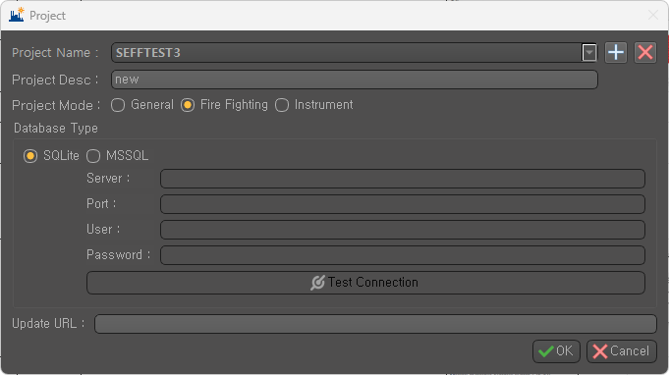

Figure 9: ID2 Project Selection UI

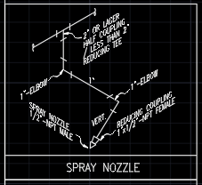

Figure 10: AutoCAD Graphic Block

# AutoCAD Import Dialog: Import Module Features

Click [Tool] - [Import AutoCAD] menu. – Figure 11

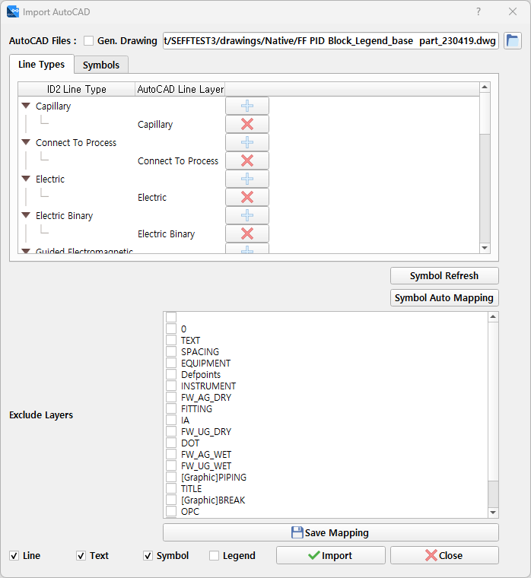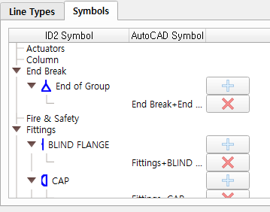

Figure 11: AutoCAD Import Dialog

1. **AutoCAD Files:** Select CAD drawings to import.
   1. **Gen. Drawing:** When checked, it generates ID2 drawings and PDF files from CAD files. When importing the drawing for the first time, you need to create the drawing. If you re-import the data without changing the drawing, uncheck this option.
2. **Line Types:** Map ID2 Line Types and CAD Line Layers.
   1. Double-click the cell in the AutoCAD Line Layer column to select the Layer to map and click the [+] button to add it.
   2. Use the [X] button to delete the mapping information.
3. **Symbols:** Map ID2 Symbols and CAD Blocks.
   1. Double-click the cell in the AutoCAD Symbols column to select the Block to map and click the [+] button to add it.
   2. Use the [X] button to delete the mapping information.
4. **Symbol Refresh:** Refresh ID2 Symbol list
5. **Symbol Auto Mapping:** When the name of the Symbol Block in the currently loaded AutoCAD drawing is the same as the name of the Symbol registered in ID2, automatic mapping is performed. This is used when importing the AutoCAD Legend to create an ID2 Symbol and map the AutoCAD Block to the ID2 Symbol.
6. **Exclude Layers:** Excludes objects on the selected Layers when importing.
7. **Save Mapping:** Saves the mapping and settings information.
8. **Line, Text, Symbol:** Sets the items to import from CAD.
9. **Legend:** When checked, it extracts Symbol Blocks from the loaded CAD drawing and registers them as ID2 Symbols.

# CAD Symbol Block Legend Import: ID2 Project Setting

Import CAD Symbol Block Legend drawings to create ID2 Symbols.

You can import multiple Legend drawings in batch if there are more than one.

1. Load CAD Symbol Block Legend drawing in [Import AutoCAD] menu.
2. Select [Legend] checkbox and click [Import] button.
3. Register CAD Blocks as ID2 Symbols in Symbol Registration window. – *Figure 13*
   1. Block shape is displayed in [Symbol Image] column.
   2. Block name and status are displayed in [Symbol Name] column.
   3. Block State is displayed in [State] column.

If an ID2 Symbol with the same name as the Block exists, it is labeled as Created. If it does not exist, it is labeled as New.

* 1. Double-click on each row to open Symbol Editor window for modification and registration. – *Figure 14*
     1. If the Symbol name is not changed from the Block name, the automatic mapping function can be used. (Recommended to not change)
     2. If the Block name follows the AutoCAD drawing rules of Category+Name, the category of the ID2 Symbol is automatically selected. If there is no matching category, the default value is Valves. If the Block name follows the rule of Equipment+Name, the category is set to Vessels.
     3. The Base Point of the CAD Block is set to the origin point. *– Figure 12*
     4. The Point of the CAD Block is set as a connection point. – *Figure 12*

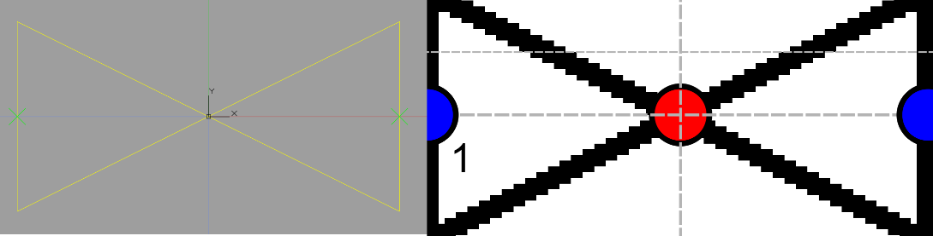

Figure 12: AutoCAD Block(Left), ID2 Symbol(Right)

* + 1. Check and modify ID2 Symbol Category, Additional Symbols, and connection point properties, and click [Save] button to save.
  1. Select the check box of the row, and press the [Create Selected Symbol] button to create the selected block in batch. (Not recommended as follow up check is required)

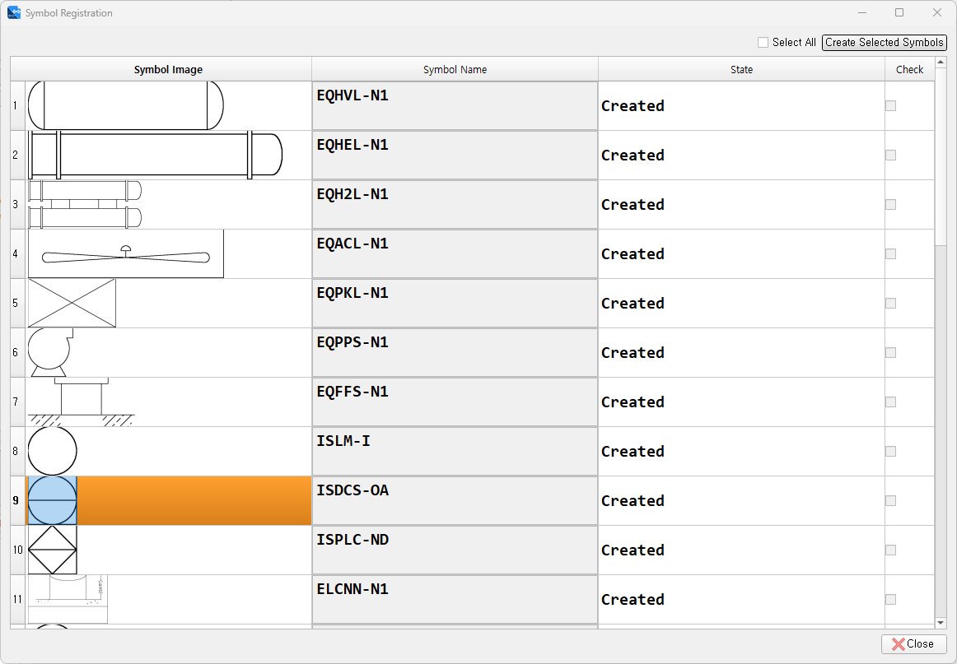

Figure 13: Symbol Registration Dialog

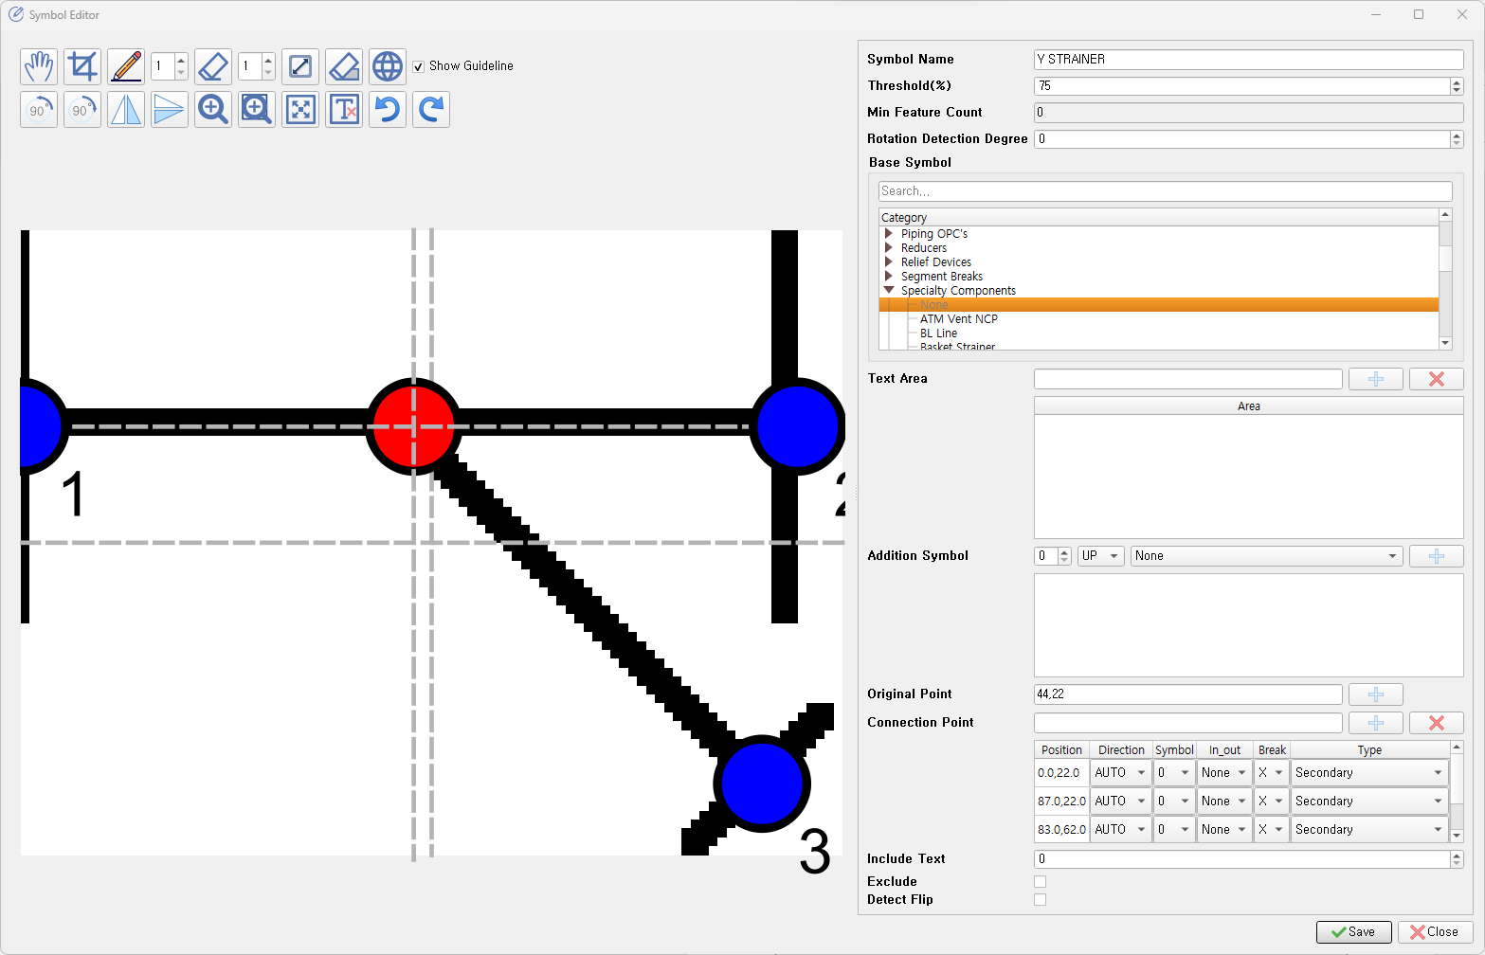

Figure 14: Symbol Editor

# CAD Layer, Block Mapping: ID2 Project Setting

Maps CAD Line Layers and Symbol Blocks to ID2 Line Types and Symbols.

1. Load the CAD Symbol Block Legend drawing from the [Import AutoCAD] menu.
2. Line Types
   1. Double-click on the [AutoCAD Line layer] column to display the Line Layers included in the Legend.
   2. Select the Layer that matches the ID2 Line Type and press the [+] button to map it.
3. Symbols
   1. Double-click on the [AutoCAD Symbol] column to display the Symbol Blocks included in the Legend.
   2. Select the Block that matches the ID2 Symbol and press the [+] button to map it.
   3. If the name of the CAD Block matches the name of the ID2 Symbol, you can use the [Auto Mapping] button for automatic mapping.
4. Press the [Save Mapping] button to save the mapping.
5. Exception: If there is a Line Layer or Symbol Block in a drawing that does not exist in the Legend AutoCAD file.
   1. Load the regular drawing.
   2. If necessary, create symbols for ID2 Symbol generation.
   3. Map the existing Block and ID2 Symbol in the drawing and save it.

# Importing CAD Drawings: ID2 Drawing Work

Imports CAD drawings into ID2.

1. Load the CAD drawing from the [Import AutoCAD] menu. (Batch import is possible)
2. Select [Line], [Text], [Symbol], and press the [Import] button.
3. Wait for the completion message.
4. Caution: If you need to re-import a drawing that has already been imported and touched-up, you must first delete all work done in ID2 and save the drawing as a blank document before re-importing it. This is to prevent duplication of symbols during the import process.

Figure 15

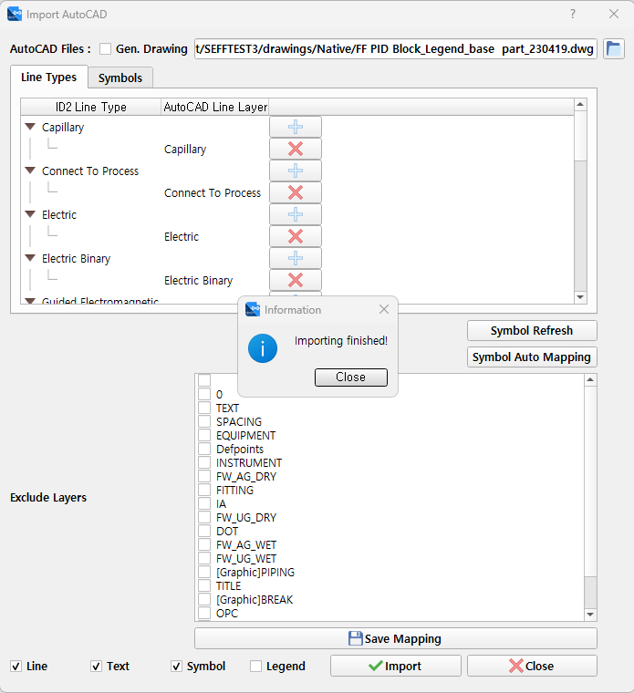

# ID2 Touch-Up: ID2 Drawing Work

Modify and connect data imported from CAD drawings in accordance with ID2 drawing rules. Here, This manual explains spelling rules considering CAD import characteristics.

1. Open the ID2 drawing with imported CAD information.
2. Import Symbols and Lines are loaded without connection.

Correct the parts that have errors due to incorrect CAD drawing rules or settings. (Modify in CAD and re-import or modify in ID2)

1. Click the [Edit] -> [Connect Symbols and Lines] button at the top of the program to create connection information
2. Modify text information on the drawing as necessary (Note, Symbol Attribute, etc.)
3. Use the [Home] -> [Link Attribute] function to create topology information.
4. Check the results and save them.

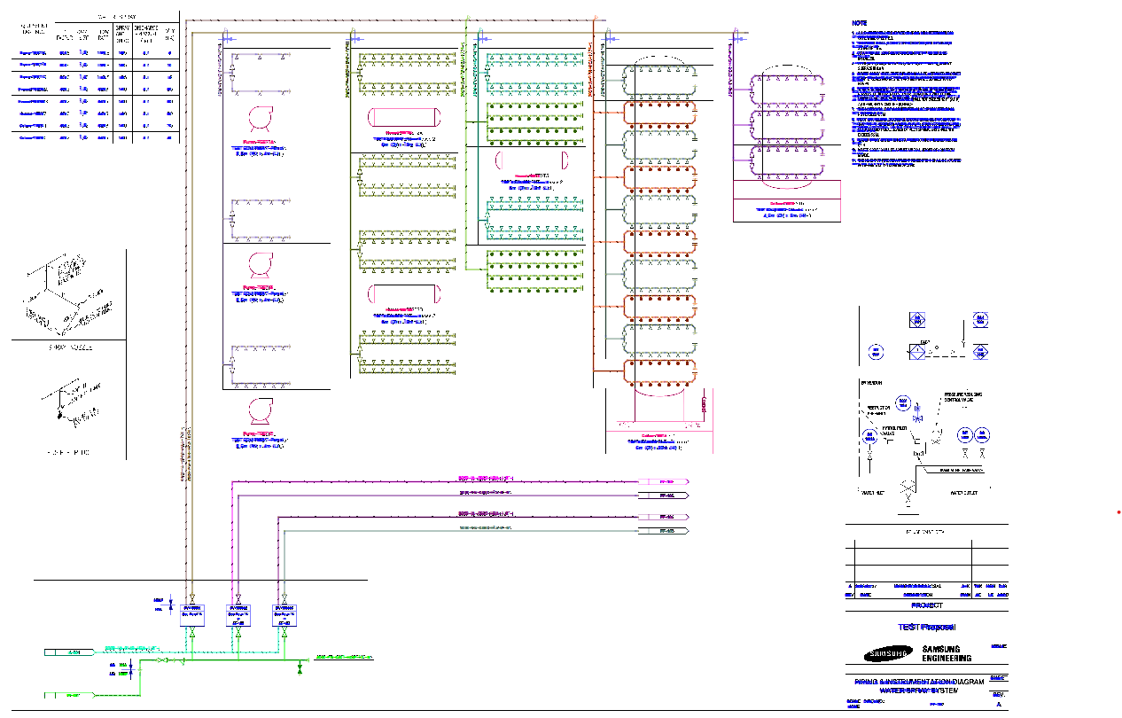

Figure 16: ID2 Working Screen

# SP P&ID Line Condition Input Feature: Pre-Work in SPPID Converter

This is a newly added Line Condition input feature in the SP P&ID Converter module. When converting the drawing, Line Condition information is automatically entered for Pipe lines based on the Line No. condition.

After running the SP P&ID Converter, go to the [Item Mapping Setting] window and click on the [PipeRun Property] tab.

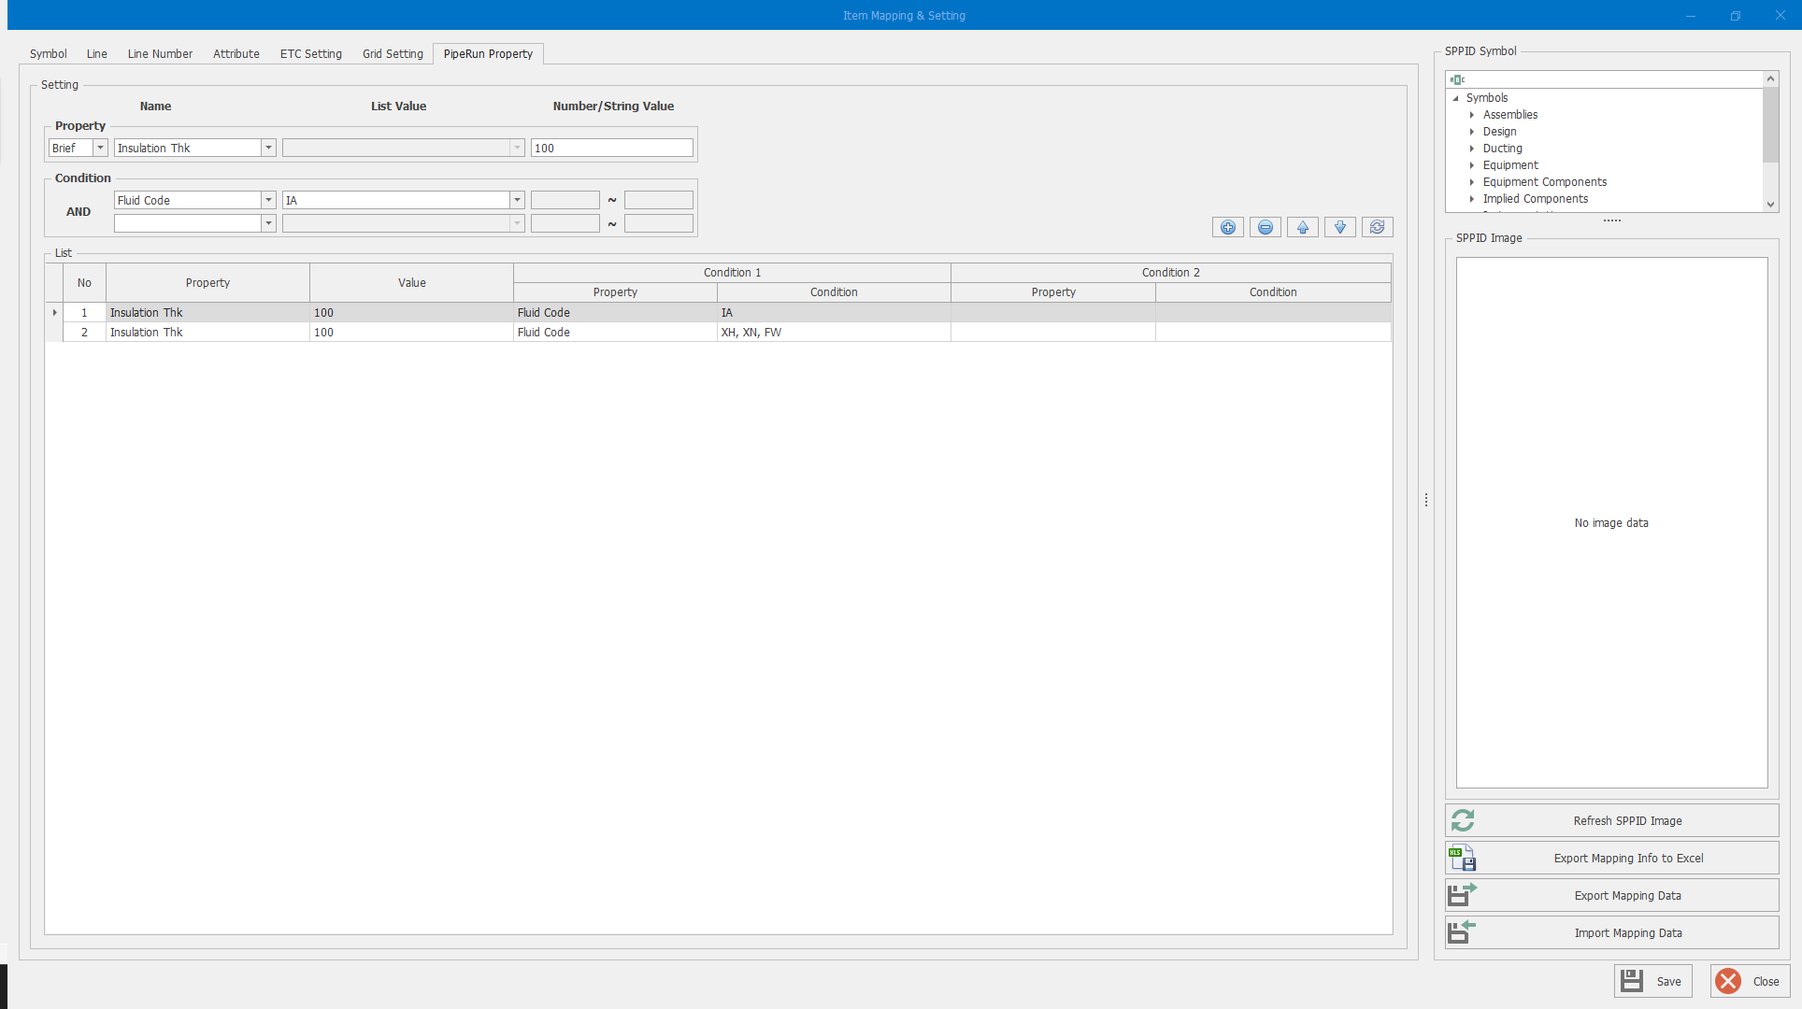

Figure 17: PipeRun Property

1. Operation buttons
   1. : Add a new condition.
   2. : Delete the selected condition.
   3. : Change the priority of the selected condition.
   4. : Refresh the list.
2. **Setting:** Set the Line Condition input conditions.
   1. **Property:** The Property to enter as Line Condition.
      1. Select the Property to enter as Line Condition from the [Name] column.

Change the scope of the displayed Property by selecting [Brief, Default, Case] from the first column list.

* + 1. Depending on the type of the selected Property, [List Value] or [Number/String Value] column will be activated.
    2. Select or enter the values to be inputted in the Condition.
  1. **Condition:** Set the condition to apply the Property. Up to 2 constraints can be set.
     1. Select the attribute to be used as a condition.
     2. Depending on the selected attribute, [List Value] or [Number/String Value] column will be activated.
     3. Select or enter the condition values. (For numbers, a range can be entered.)

1. **List:** Displays the set conditions.
   1. The upper item in the list is applied first (from No. 1)
   2. To modify an existing item, select the corresponding row and modify it in the [Setting] section.

# SP P&ID Converting: SPPID Drawing Work

The pre-settings and conversion process are the same as the ID2 Converter.

When converting an ID2 drawing through import to a CAD drawing, the grid is adjusted according to the drawing rules, and the graphic items are automatically converted into auxiliary graphics format.

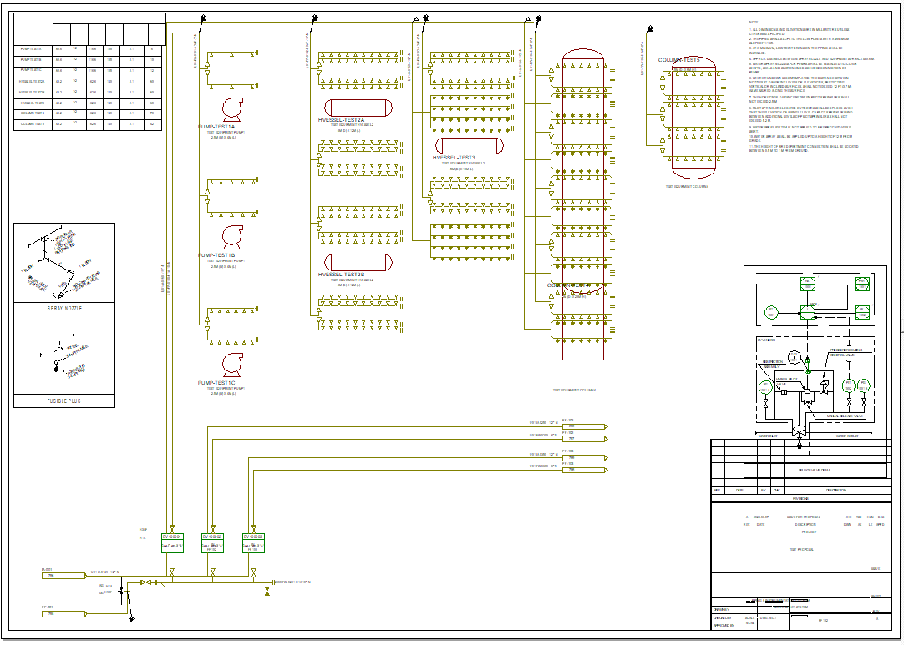

Figure 18: SPPID Result

# SP P&ID Touch-Up: SPPID Drawing Work

The SP P&ID Touch-Up follows ID2 Converter and SP P&ID drawing rules, and here this manual explains the spellings considering the CAD import characteristics.

1. Modify the position and size of Parametric Equipment.
2. Adjust the position of Text and Label.
3. Organize table-style data and notes.
4. Organize the position of Break symbols.
5. Perform OPC connection.