Fire Fighting CAD Drawing Importing

Cad drafting, Importing GUIDE

2023

목차

1. CAD Importing Module 2

2. CAD 도면 작도 규칙 3

3. CAD Symbol Block Legend 5

4. ID2 Project 동작 모드 변경 7

5. CAD Import Dialog 8

6. CAD Symbol Block Legend Import 10

7. CAD Layer, Block Mapping 12

8. CAD 도면 Importing 13

9. ID2 Touch-Up 14

10. SP P&ID Line Condition 입력 기능 15

11. SP P&ID Converting 17

12. SP P&ID Touch-Up 18

# CAD Importing Module

The ID2 CAD Importing Module imports drawings created in CAD to generate intelligent drawings in ID2.

It imports symbols, text, and lines from CAD drawings drawn according to defined rules.

Symbols should be used as CAD blocks, and lines should be separated by layer according to their types.

The CAD Importing process includes creating a CAD Symbol Block Legend, creating a CAD drawing, importing a CAD Symbol Block Legend (creating ID2 symbols), mapping CAD information, importing CAD drawings, and performing ID2 drawing correction tasks.

# CAD Drawing Rules

The following rules apply to CAD drawing for ease of ID2 import and SPPID conversion.

1. General
   1. CAD units are in mm.
   2. CAD grids are drawn to fit the grid using 1.27mm.
   3. Symbol Blocks, Pipe Lines, and Signal Lines are drawn with a minimum of 1 grid. (2 grids or more recommended)
   4. Avoid drawing diagonal and curved lines. (Ellipses are not allowed)
   5. CAD drawings should only be drawn within the Border Template. (including Legend)
   6. Place the lower left corner of the Border Template at 0,0.
   7. Use the same shape for the Border in CAD and the Border Template in SPPID.
   8. If a block is a library, not a single symbol, set the block name as Piping+Name. (Ex. Piping+HIA-N234)
2. Line
   1. 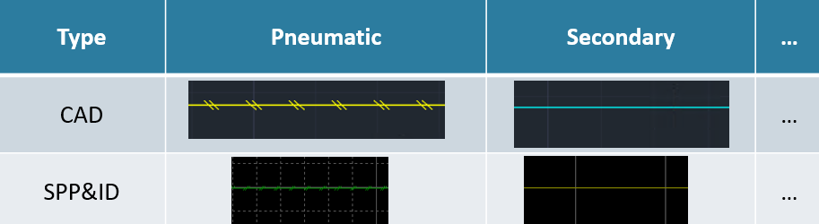 Use layers based on the type of the line. (Ex: Primary, Secondary, Electric, Software, Connect to Process, etc.)
   2. If the line is part of a block, draw the line on the same layer of line drawn outside.
   3. If the line needs to branch in SPPID, separate the line in CAD as well.
   4. When three lines meet, draw the length of the main line longer than the branch line. (if necessary, divide the branch line)

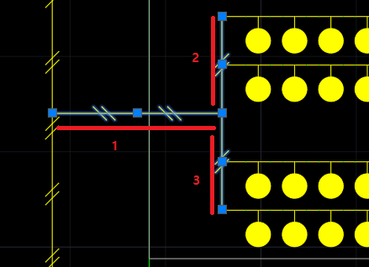

1. Symbol
   1. Use the CAD block that corresponds 1:1 to the SPPID symbol.
   2. The unit symbol block should not include other blocks inside. (If the shape is the same, explode and save)
   3. If the same shape in CAD is converted into a different symbol in SPPID, use a different block.
   4. Set the position of the INSBASE(0,0) of the symbol block to match the origin of the SPPID symbol.
   5. Insert connection points of the SPPID symbol into the CAD symbol block as a Point.
   6. Set the 0-degree shape of the SPPID symbol and the CAD symbol block to match.
   7. CAD Symbol Block Name is set to ID2 Category+Symbol Name (Ex: Valves+Gate Valve, for Symbol Mapping automation)
   8. Graphic Conversion Block Name is set to Graphic+Name. (Ex: Graphic+Detail WsNozzle)

# CAD Line and Symbol Block Legend

Create a legend for all lines and symbols used in creating CAD drawings.

Use these lines and symbols to create a CAD Block Library and generate CAD drawings.

And import the legend into ID2 to create and map ID2 Symbols.

1. Arrange the symbols at 0 degree.
2. Sort the lines used in the drawing (Piping, Signal) by layer.

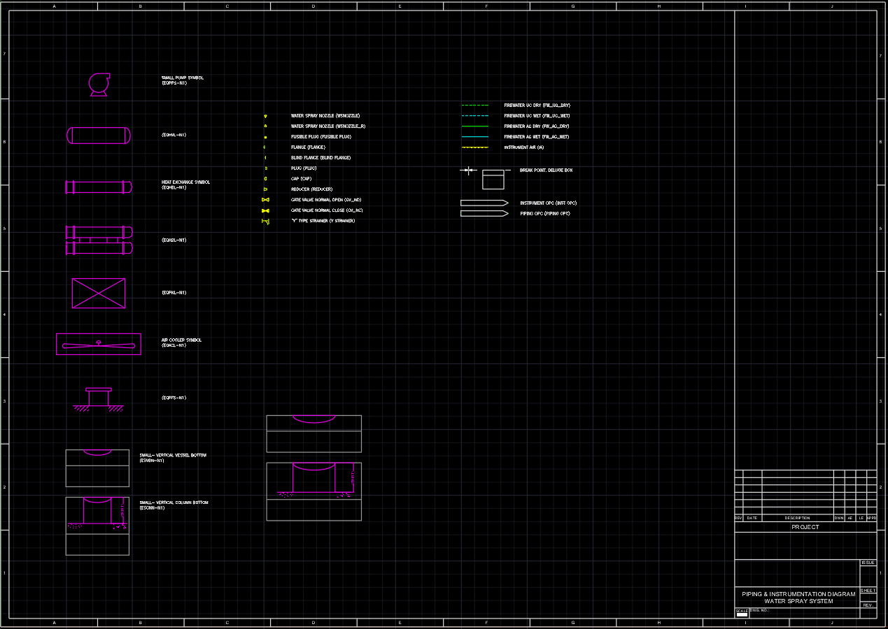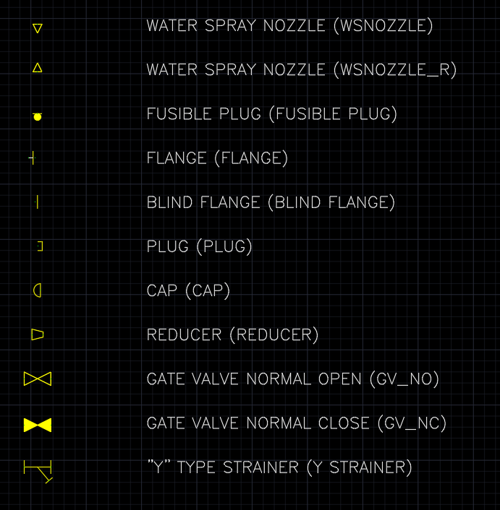

1. Draw all CAD drawings and Block Libraries using only the Blocks defined in the legend.
   1. 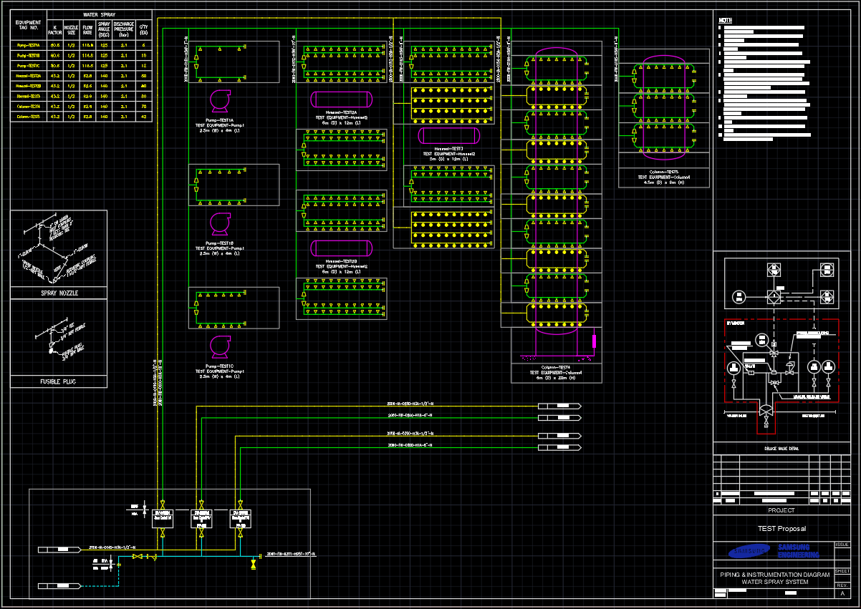Block Library: Blocks created using Symbols defined in the legend are used in the CAD drawing automation program.

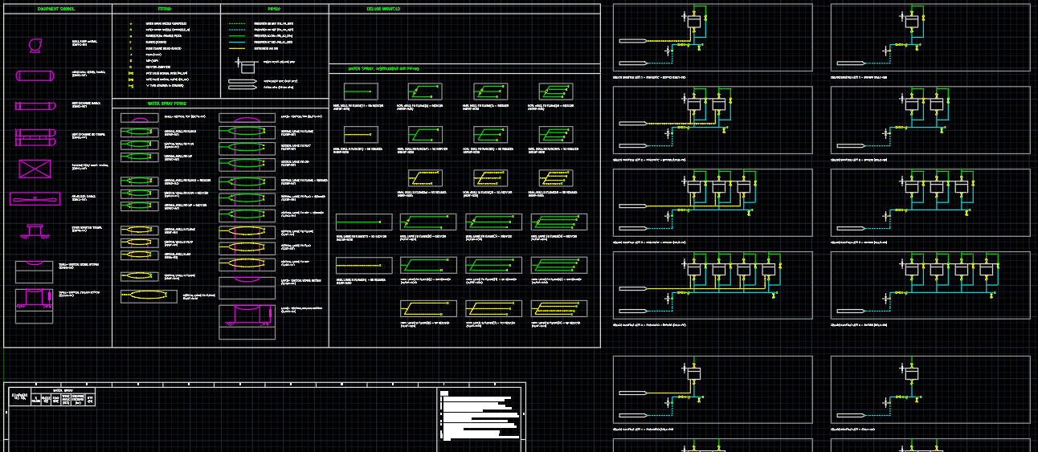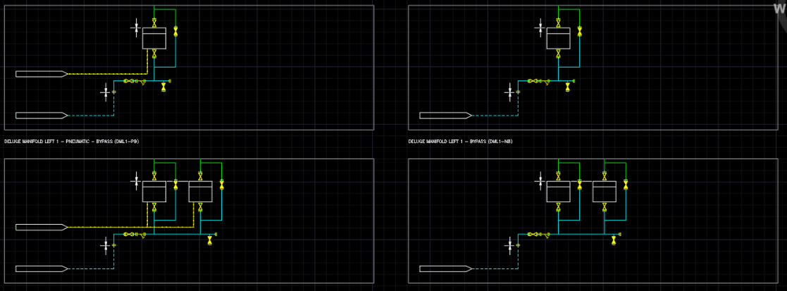

# ID2 Project Mode Change

After running ID2, select or create a project, then change the [Project Mode].

Each mode has defined functions and themes, which can be changed in settings after execution.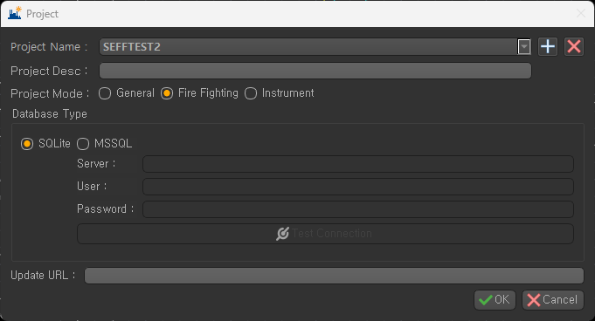

# CAD Import Dialog

Click [Tool] - [Import AutoCAD] menu.

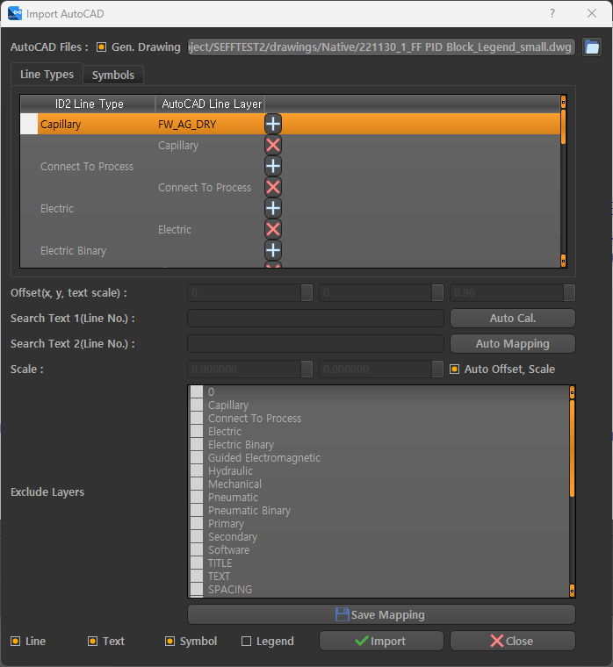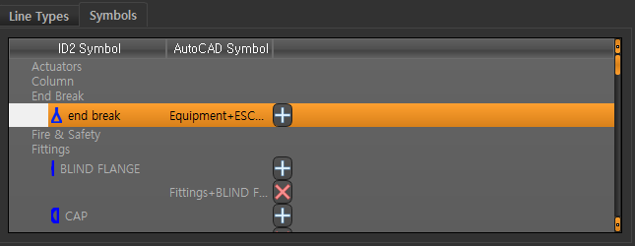

1. **AutoCAD Files:** Select CAD drawings to import.
   1. **Gen. Drawing:** When checked, it generates ID2 drawings and PDF files from CAD files. When importing the drawing for the first time, you need to create the drawing. If you re-import the data without changing the drawing, uncheck this option.
2. **Line Types:** Map ID2 Line Types and CAD Line Layers.
   1. Double-click the cell in the AutoCAD Line Layer column to select the Layer to map and click the [+] button to add it.
   2. Use the [X] button to delete the mapping information.
3. **Symbols:** Map ID2 Symbols and CAD Blocks.
   1. Double-click the cell in the AutoCAD Symbols column to select the Block to map and click the [+] button to add it.
   2. Use the [X] button to delete the mapping information.
4. **Auto Offset, Scale:** When checked, it automatically calculates and imports the Offset and Scale of the CAD drawing based on the Board. If unchecked, you need to input the Line No. Text to use as a reference for the calculation.
   1. **Offset(x, y, text scale):** Moves the CAD object by the x and y values and corrects the length of the Text by the text scale.
   2. **Auto Cal.:** Calculates the Offset and Scale by searching for the Line No. entered in Search Text1(Line No.) and Search Text2(Line No.) on the CAD drawing. (Requires ID2 Line No. settings)
   3. **Scale:** Adjusts the ratio of the CAD drawing to the ID2 drawing.
5. **Auto Mapping:** If the name of the Symbol Block loaded in the current CAD drawing matches the name of a Symbol registered in ID2, automatic mapping is performed.
6. **Exclude Layers:** Excludes objects on the selected Layers when importing.
7. **Save Mapping:** Saves the mapping and settings information.
8. **Line, Text, Symbol:** Sets the items to import from CAD.
9. **Legend:** When checked, it extracts Symbol Blocks from the loaded CAD drawing and registers them as ID2 Symbols.

# CAD Symbol Block Legend Import

Import CAD Symbol Block Legend drawings to create ID2 Symbols.

1. Load CAD Symbol Block Legend drawing in [Import AutoCAD] menu.
2. Select [Legend] checkbox and click [Import] button.
3. Register CAD Blocks as ID2 Symbols in Symbol Registration window.
   1. Block shape is displayed in [Symbol Image] column.
   2. Block name and status are displayed in [Symbol Info] column.

If an ID2 Symbol with the same name as the Block exists, it is labeled as Created. If it does not exist, it is labeled as New.

* 1. Double-click on each row or select and click [Create] button to open Symbol Editor window for modification and registration.
     1. If the Symbol name is not changed from the Block name, the automatic mapping function can be used. (recommended to not change)
     2. If the Block name follows CAD drafting rules as Category + Name, ID2 Symbol's category is automatically selected, and if there is no matching category, Valves or Vessels is selected as the default.
     3. The Base Point of the CAD Block is set to the origin point.
     4. The Point of the CAD Block is set as a connection point.
     5. Check and modify ID2 Symbol Category, Additional Symbols, and connection point properties, and click [Save] button to save.
  2. Select [State] checkbox and click [Create All] button to create all selected Blocks at once. (Not recommended as follow up check is required)

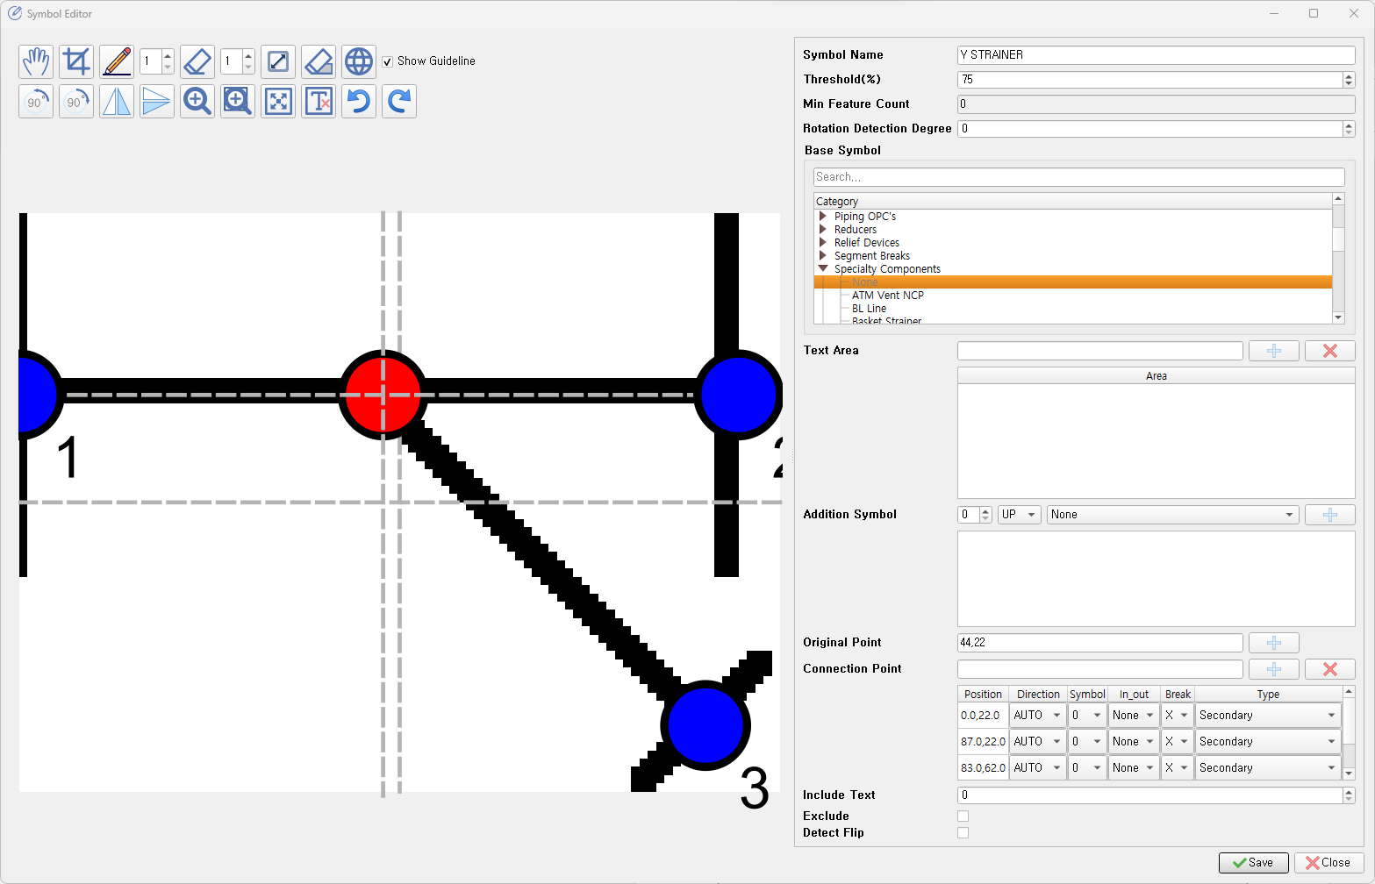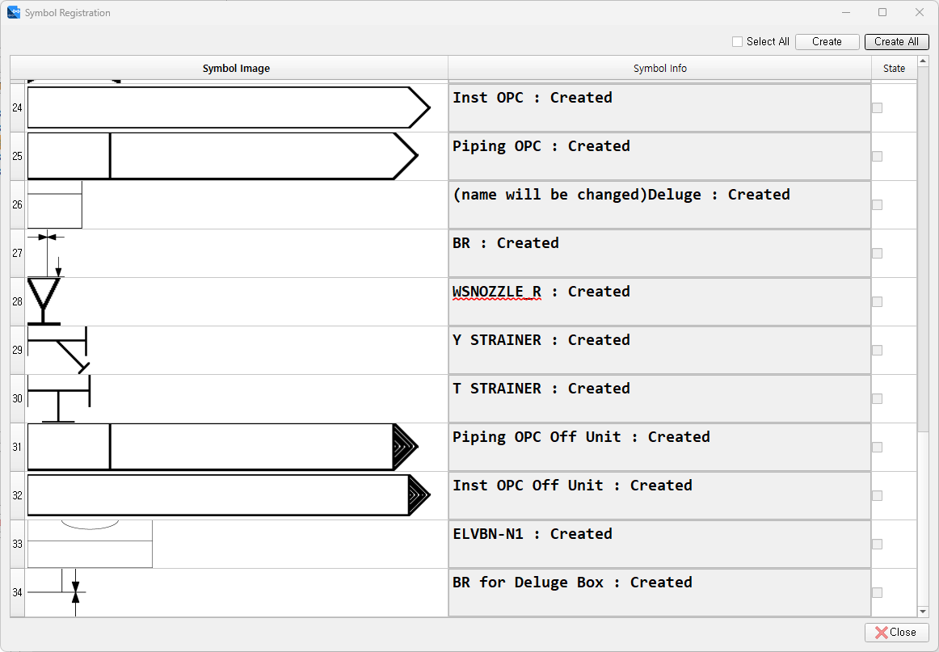

# CAD Layer, Block Mapping

Maps CAD Line Layers and Symbol Blocks to ID2 Line Types and Symbols.

1. Load the CAD Symbol Block Legend drawing from the [Import AutoCAD] menu.
2. Line Types
   1. Double-click on the [AutoCAD Line layer] column to display the Line Layers included in the Legend.
   2. Select the Layer that matches the ID2 Line Type and press the [+] button to map it.
3. Symbols
   1. Double-click on the [AutoCAD Symbol] column to display the Symbol Blocks included in the Legend.
   2. Select the Block that matches the ID2 Symbol and press the [+] button to map it.
   3. If the name of the CAD Block matches the name of the ID2 Symbol, you can use the [Auto Mapping] button for automatic mapping.
4. Press the [Save Mapping] button to save the mapping.

# CAD 도면 Importing

Imports CAD drawings into ID2.

1. Load the CAD drawing from the [Import AutoCAD] menu. (Batch import is possible)
2. Select [Line], [Text], [Symbol], and press the [Import] button.
3. 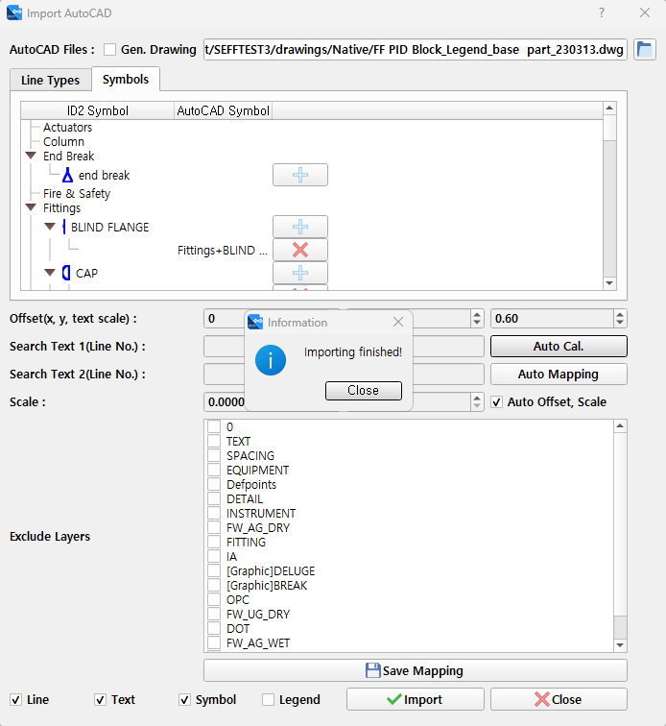 Wait for the completion message.

# ID2 Touch-Up

Modify and connect data imported from CAD drawings in accordance with ID2 drawing rules. Here, This manual explains spelling rules considering CAD import characteristics.

1. Open the ID2 drawing with imported CAD information.
2. Import Symbols and Lines are loaded without connection.

Correct the parts that have errors due to incorrect CAD drawing rules or settings. (Modify in CAD and re-import or modify in ID2)

1. Click the [Edit] -> [Connect Symbols and Lines] button at the top of the program to create connection information
2. Modify text information on the drawing as necessary (Note, Symbol Attribute, etc.)
3. Use the [Home] -> [Link Attribute] function to create topology information.
4. 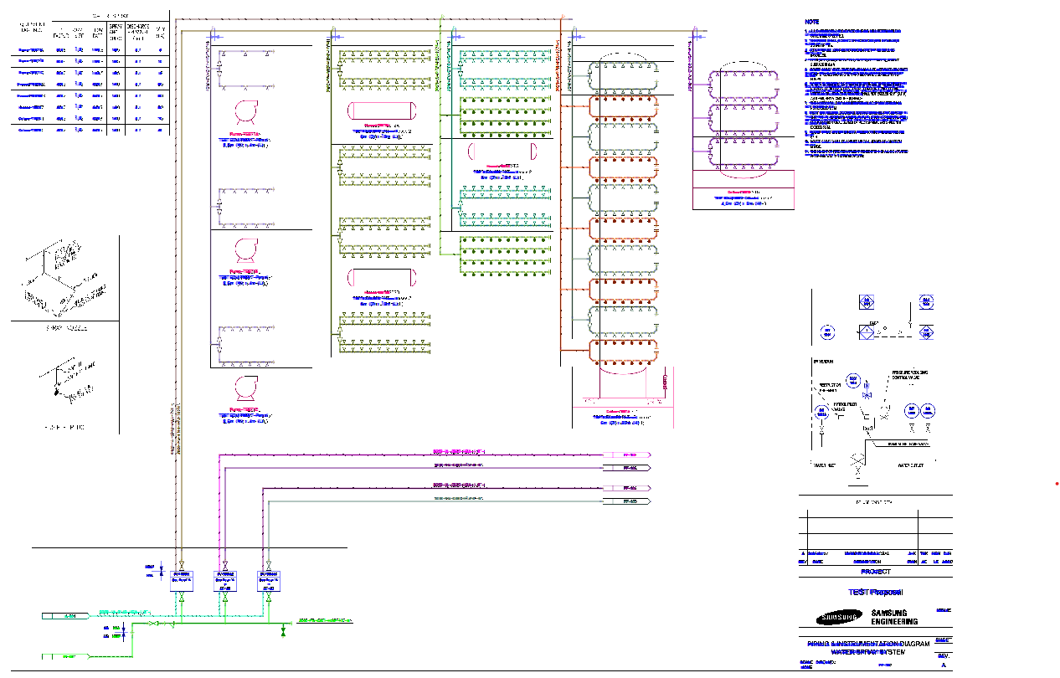 Check the results and save them.

# SP P&ID Line Condition 입력 기능

This is a newly added Line Condition input feature in the SP P&ID Converter module. When converting the drawing, Line Condition information is automatically entered for Pipe lines based on the Line No. condition.

After running the SP P&ID Converter, go to the [Item Mapping Setting] window and click on the [PipeRun Property] tab.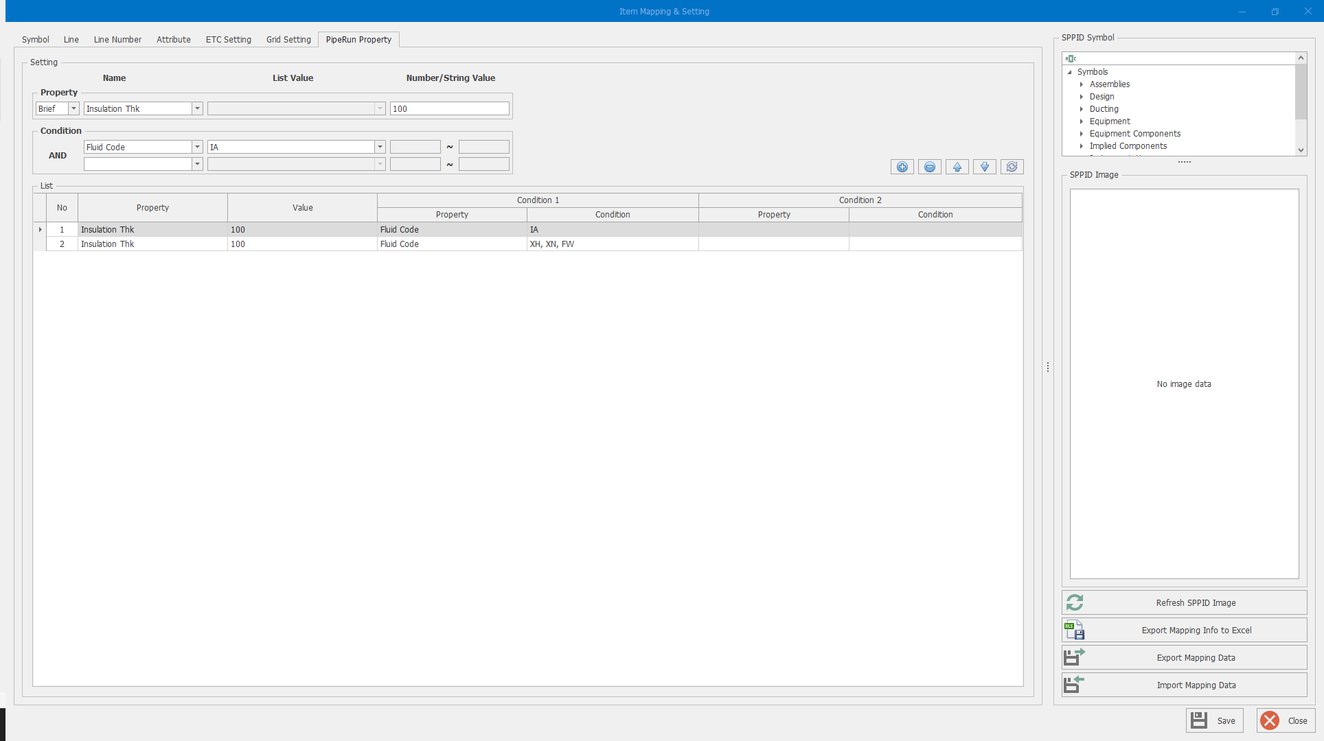

1. Operation buttons
   1. : Add a new condition.
   2. : Delete the selected condition.
   3. : Change the priority of the selected condition.
   4. : Refresh the list.
2. **Setting:** Set the Line Condition input conditions.
   1. **Property:** The Property to enter as Line Condition.
      1. Select the Property to enter as Line Condition from the [Name] column.

Change the scope of the displayed Property by selecting [Brief, Default, Case] from the first column list.

* + 1. Depending on the type of the selected Property, [List Value] or [Number/String Value] column will be activated.
    2. Select or enter the values to be inputted in the Condition.
  1. **Condition:** Set the condition to apply the Property. Up to 2 constraints can be set.
     1. Select the attribute to be used as a condition.
     2. Depending on the selected attribute, [List Value] or [Number/String Value] column will be activated.
     3. Select or enter the condition values. (For numbers, a range can be entered.)

1. **List:** Displays the set conditions.
   1. The upper item in the list is applied first (from No. 1)
   2. To modify an existing item, select the corresponding row and modify it in the [Setting] section.

# SP P&ID Converting

The pre-settings and conversion process are the same as the ID2 Converter.

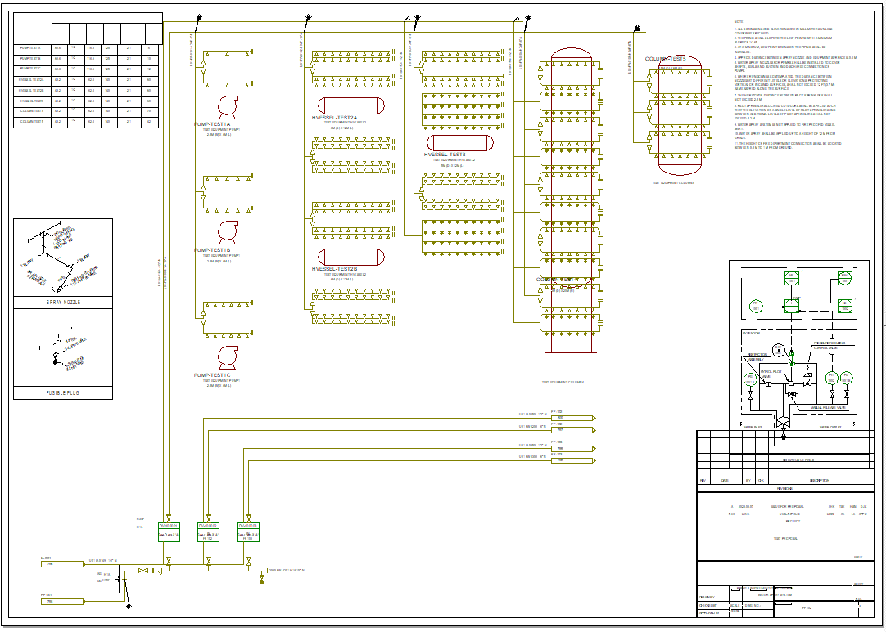When converting an ID2 drawing through import to a CAD drawing, the grid is adjusted according to the drawing rules, and the graphic items are automatically converted into auxiliary graphics format.

# SP P&ID Touch-Up

The SP P&ID Touch-Up follows ID2 Converter and SP P&ID drawing rules, and here this manual explains the spellings considering the CAD import characteristics.

1. Modify the position and size of Parametric Equipment.
2. Adjust the position of Text and Label.
3. Organize table-style data and notes.
4. Organize the position of Break symbols.
5. Perform OPC connection.